[Skip to main content](https://link-springer-com.erl.lib.byu.edu/article/10.1007/s11042-018-6216-x#main-content)[Skip to sections](https://link-springer-com.erl.lib.byu.edu/article/10.1007/s11042-018-6216-x#article-contents)

Advertisement

Hide

[SpringerLink](https://link-springer-com.erl.lib.byu.edu/" \o "Go to homepage)

[Search](https://link-springer-com.erl.lib.byu.edu/article/10.1007/s11042-018-6216-x#search-container)

* [Home](https://link-springer-com.erl.lib.byu.edu/)

* [Log in](https://link-springer-com.erl.lib.byu.edu/signup-login?previousUrl=https%3A%2F%2Flink.springer.com%2Farticle%2F10.1007%2Fs11042-018-6216-x)

[Multimedia Tools and Applications[](https://link-springer-com.erl.lib.byu.edu/journal/11042)](https://link-springer-com.erl.lib.byu.edu/journal/11042)

[Multimedia Tools and Applications](https://link-springer-com.erl.lib.byu.edu/journal/11042)

December 2018, Volume 77, [Issue 23](https://link-springer-com.erl.lib.byu.edu/journal/11042/77/23/page/1), pp 30651–30682| [Cite as](https://link-springer-com.erl.lib.byu.edu/article/10.1007/s11042-018-6216-x#citeas)

Virtual reality training for assembly of hybrid medical devices

* [Authors](https://link-springer-com.erl.lib.byu.edu/article/10.1007/s11042-018-6216-x#authors)
* [Authors and affiliations](https://link-springer-com.erl.lib.byu.edu/article/10.1007/s11042-018-6216-x#authorsandaffiliations)
* Nicholas Ho
* Pooi-Mun Wong
* Matthew Chua
* Chee-Kong Chui

1. 1.
2. 2.

Article

**First Online:**31 May 2018

* 243Downloads

Abstract

Skill training in the medical device manufacturing industry is essential to optimize and expedite the efficiency level of new workers. This process, however, gives rise to many underlying issues such as contamination and safety risks, long training period, high skill and experience requirements of operators, and greater training costs. In this paper, we proposed and evaluated a novel virtual reality (VR) training system for the assembly of hybrid medical devices. The proposed system, which is an integration of Artificial Intelligence (AI), VR and gaming concepts, is self-adaptive and autonomous. This enables the training to take place in a virtual workcell environment without the supervision of a physical trainer. In this system, a sequential framework is proposed and utilized to enhance the training through its various “game” levels of familiarity-building processes. A type of hybrid medical device: carbon nanotubes-polydimethylsiloxane (CNT-PDMS) based artificial trachea prosthesis is used as a case study in this paper to demonstrate the effectiveness of the proposed system. Evaluation results with quantitative and qualitative comparisons demonstrated that our proposed training method has significant advantages over common VR training and conventional training methods. The proposed system has addressed the underlying training issues for hybrid medical device assembly by providing trainees with effective, efficient, risk-free and low cost training.

Keywords

Interactive training environment Virtual reality Virtual assembly workcell Hybrid medical device Assembly training

Access to this content is enabled by **BYU Library**

1 Introduction

1.1 Hybrid medical device fabrication

Medical devices, in particular, hybrid medical devices comprise of multiple materials, which include both synthetic and biological components (e.g. nanotubes, polymers, stem cells, deoxyribonucleic acid) [[8](https://link-springer-com.erl.lib.byu.edu/article/10.1007/s11042-018-6216-x#CR8), [38](https://link-springer-com.erl.lib.byu.edu/article/10.1007/s11042-018-6216-x#CR38), [42](https://link-springer-com.erl.lib.byu.edu/article/10.1007/s11042-018-6216-x#CR42)]. Cells, a commonly used biological material for hybrid devices, is a critical consideration in the development and modelling of hybrid medical device fabrication processes [[18](https://link-springer-com.erl.lib.byu.edu/article/10.1007/s11042-018-6216-x#CR18), [35](https://link-springer-com.erl.lib.byu.edu/article/10.1007/s11042-018-6216-x#CR35)]. As hybrid medical devices require a series of controlled and specialized processes, the assembly of hybrid medical devices is considered to be a highly complex and time-consuming process. Furthermore, the working environment has to be free from contamination throughout the fabrication and preparation process [[18](https://link-springer-com.erl.lib.byu.edu/article/10.1007/s11042-018-6216-x#CR18), [31](https://link-springer-com.erl.lib.byu.edu/article/10.1007/s11042-018-6216-x#CR31)]. Although physical robot aids are commonly used to reduce over-reliance on human skills and abilities [[26](https://link-springer-com.erl.lib.byu.edu/article/10.1007/s11042-018-6216-x#CR26)], they may not be feasible in this application because of the complexity in the assembly process, and thus questioning the feasibility of Human-Robot Collaboration (HRC) and fully automated based assembly for such application types. Thereby, concluding that manual assembly is the most suitable approach for such complex tasks with relatively low volume [[15](https://link-springer-com.erl.lib.byu.edu/article/10.1007/s11042-018-6216-x#CR15)].

As hybrid medical device fabrication involves manual assembly due to its complex nature, skill training in this industry is essential to optimize and expedite the efficiency level of new assembly operators [[5](https://link-springer-com.erl.lib.byu.edu/article/10.1007/s11042-018-6216-x#CR5), [19](https://link-springer-com.erl.lib.byu.edu/article/10.1007/s11042-018-6216-x#CR19)]. Traditional, existing training methods for manual assembly include mentoring and attending lectures in classrooms. However, these methods pose many problems such as difficulty in transferring tacit skill/knowledge to the trainees and the requirement of intensive guidance by qualified manager or supervisor [[33](https://link-springer-com.erl.lib.byu.edu/article/10.1007/s11042-018-6216-x#CR33)]. This training process also gives rise to other underlying issues such as long training period, high skill and experience requirements of operators, and high training costs [[25](https://link-springer-com.erl.lib.byu.edu/article/10.1007/s11042-018-6216-x#CR25)]. Moreover, the training is likely to be executed within a shared workcell among other existing operators due to the high costs involved in purchasing, constructing and/or maintaining the equipment and the cleanroom [[19](https://link-springer-com.erl.lib.byu.edu/article/10.1007/s11042-018-6216-x#CR19)]. In such case, the training process may lead to an increase in contamination and safety risks, which is not desirable for hybrid medical device fabrication [[2](https://link-springer-com.erl.lib.byu.edu/article/10.1007/s11042-018-6216-x#CR2), [41](https://link-springer-com.erl.lib.byu.edu/article/10.1007/s11042-018-6216-x#CR41)]. In order to solve these underlying issues, a risk-free, low cost and efficient assembly guidance training system has to be introduced.

1.2 Virtual reality (VR) training

Virtual reality (VR) technology is recognised as a useful tool for physical skills training. By definition, VR is a technology that allows user interaction and engagement within virtual worlds that are generated by computers [[17](https://link-springer-com.erl.lib.byu.edu/article/10.1007/s11042-018-6216-x#CR17), [21](https://link-springer-com.erl.lib.byu.edu/article/10.1007/s11042-018-6216-x#CR21)]. The main advantage of developing a VR system is that, it enables the users to interactively update the simulation and input new control orders in a virtual environment by directly updating the virtual objects and operations in real time [[57](https://link-springer-com.erl.lib.byu.edu/article/10.1007/s11042-018-6216-x#CR57)]. VR training systems have been implemented in many training disciplines such as military, engineering, flight simulation, automotive, space and manufacturing [[22](https://link-springer-com.erl.lib.byu.edu/article/10.1007/s11042-018-6216-x#CR22), [52](https://link-springer-com.erl.lib.byu.edu/article/10.1007/s11042-018-6216-x#CR52)]. Because of increasing demand for mobility, VR training is increasingly available over the Internet and ad-hoc wireless networks. This, however, leads to increased handling complexity and higher quality goals at run time [[52](https://link-springer-com.erl.lib.byu.edu/article/10.1007/s11042-018-6216-x#CR52)]. Moreover, as every trainee learns differently and may require their training to focus on certain aspects of the tasks, VR training systems also face another challenge, which is to customise the training to suit individual learning patterns. This customisation process conventionally involves human supervision that is time consuming and costly. In order to solve this issue, a self-adaptive and autonomous VR training system can be implemented to automate and customise training for each trainee. As a result, it can not only eliminate the need for human supervision, but also increase training effectiveness and efficiency [[52](https://link-springer-com.erl.lib.byu.edu/article/10.1007/s11042-018-6216-x#CR52)].

VR technologies are widely considered in manufacturing industries because it can improve manufacturing operations, leading to efficient and effective learning and training, and hence increasing productivity, improving quality and reducing cost. Moreover, these technologies can address complex problems in manufacturing. VR training simulations, which are usually conducted before the actual operations, have the capability to eliminate the amount of errors, trials and re-works that are to be incurred during actual operations, and thus saving energy, materials and labour [[34](https://link-springer-com.erl.lib.byu.edu/article/10.1007/s11042-018-6216-x#CR34), [37](https://link-springer-com.erl.lib.byu.edu/article/10.1007/s11042-018-6216-x#CR37), [40](https://link-springer-com.erl.lib.byu.edu/article/10.1007/s11042-018-6216-x#CR40)]. Research on VR manufacturing applications has progressed significantly over the past decade due to advances in both hardware and software, and thus making it a potential and attractive research topic. Hardware has become noticeably more powerful and smaller, while many robust and efficient algorithms have been developed to speed up response and to improve accuracy in tracking and registration [[34](https://link-springer-com.erl.lib.byu.edu/article/10.1007/s11042-018-6216-x#CR34)].

According to Brough et al. [[5](https://link-springer-com.erl.lib.byu.edu/article/10.1007/s11042-018-6216-x#CR5)], training effectiveness, efficiency and cost can be further improved by utilizing VR technology, which have the potential to expedite the training process. They also highlighted that during VR training, providing images of equipment/materials/tools and visual hints via animations in a 3D setting, and allowing practice of the assembly tasks are helpful for trainees, as these aids/practices help in the transfer of knowledge to real life applications. This cognitive based training method enables trainees to learn to recognize/remember assembly parts and sequences, and to handle the parts correctly during assembly operations. In addition, Hyppölä et al. [[21](https://link-springer-com.erl.lib.byu.edu/article/10.1007/s11042-018-6216-x#CR21)] also highlighted that VR is capable of enhancing learning experience by providing experiential learning in acquiring new skills. Moreover, it was also mentioned that VR can be used to (a) create effective virtual environments that are not available or easily accessible in the real world, (b) provide a safe, low-cost training method with no harm/risk for patients in the medical industry, (c) support active learning and repeated task practices.

In light of these advantages, the integration of VR technology will be able to help solve the previously mentioned underlying training issues for hybrid medical device assembly. As a VR based assembly training system does not require (a) physical equipment [[22](https://link-springer-com.erl.lib.byu.edu/article/10.1007/s11042-018-6216-x#CR22)], (b) built-in cleanroom system [[22](https://link-springer-com.erl.lib.byu.edu/article/10.1007/s11042-018-6216-x#CR22)], (c) physical training manager/supervisor [[52](https://link-springer-com.erl.lib.byu.edu/article/10.1007/s11042-018-6216-x#CR52)], and (d) long training period (because it can reduce/skip “waiting time”), it is also able to provide risk-free, low cost and efficient training [[44](https://link-springer-com.erl.lib.byu.edu/article/10.1007/s11042-018-6216-x#CR44), [52](https://link-springer-com.erl.lib.byu.edu/article/10.1007/s11042-018-6216-x#CR52)] apart from its main advantage of being effective as discussed earlier.

2 Related works

VR technology plays an important role in simulating advanced 3D human-computer interactions (HCI), especially for mechanical assemblies, by allowing operators to be fully immersed in an artificial environment [[22](https://link-springer-com.erl.lib.byu.edu/article/10.1007/s11042-018-6216-x#CR22), [34](https://link-springer-com.erl.lib.byu.edu/article/10.1007/s11042-018-6216-x#CR34)]. HCI technologies have enabled computers to approximately replicate human activities and dynamics behaviours of the virtual objects in a virtual environment [[57](https://link-springer-com.erl.lib.byu.edu/article/10.1007/s11042-018-6216-x#CR57)]. Many VR-based systems have been proposed and could assist training activities successfully, in particular assembly training activities [[22](https://link-springer-com.erl.lib.byu.edu/article/10.1007/s11042-018-6216-x#CR22), [34](https://link-springer-com.erl.lib.byu.edu/article/10.1007/s11042-018-6216-x#CR34)].

2.1 VR training for assembly activities

Developed VR training methods for assembly activities include Brough et al. [[5](https://link-springer-com.erl.lib.byu.edu/article/10.1007/s11042-018-6216-x#CR5)] who developed a virtual environment-based training system for simple mechanical assembly operations. The system consists of 3 components: (a) virtual workspace that is responsible to dynamically generate animations, (b) virtual author that allows trainers to create a VR-based tutorial without doing any programming, and (c) virtual mentor that monitors the operator actions in the virtual workspace and assists him/her when necessary via various forms of instructions. It was proven effective in training new operators based on conducted user study. In the work by Xia et al. [[55](https://link-springer-com.erl.lib.byu.edu/article/10.1007/s11042-018-6216-x#CR55)], a haptics-based virtual environment system is developed for complex product assembly training. This system is based on a rebuilt hierarchical constraint-based data model and it builds the virtual assembly environment using a programme. This programme automatically integrates data to transfer relevant data to a VR application from a computer-aided design system. Haptics feedback and physics-based modelling methods are utilized to simulate the assembly operations. Experiment results illustrated the potential of this proposed application for assembly training processes. Another work by Müller et al. [[33](https://link-springer-com.erl.lib.byu.edu/article/10.1007/s11042-018-6216-x#CR33)] includes introducing a concept in which VR based simulation-games are used to support training for industrial manual assembly processes. This concept involves a tutorial game (Assembly Game) that aims to give trainees an initial understanding of the assembly steps, and a practical training session (Gaming System). Their human trial studies proved that the concept was effective. Wasfy et al. [[54](https://link-springer-com.erl.lib.byu.edu/article/10.1007/s11042-018-6216-x#CR54)] developed an intelligent virtual environment that has the potential to effectively train users in complex engineering system operations. The system involves an intelligent agent that tutors, guides and/or supervises the process training and it comprises of three main components: (a) a rule-based expert system, (b) a hierarchical process knowledge base, and (c) a human-like virtual characters engine. Stratos et al. [[48](https://link-springer-com.erl.lib.byu.edu/article/10.1007/s11042-018-6216-x#CR48)] also introduces an innovative VR, game based learning framework that aims to attract young students at secondary level to manufacturing. It involves using a CAVE (an immersive VR environment) to simulate manual assembly tasks. Experiment results illustrated the increase in interest by the secondary students in the assembly process. Besides the emergence of new frameworks, researchers have also been investigating on analysis methods for VR training. One example is the new task analysis method recommended and developed by Yuviler-Gavish et al. [[58](https://link-springer-com.erl.lib.byu.edu/article/10.1007/s11042-018-6216-x#CR58)] for developing maintenance and assembly VR training simulators. The proposed method, which was based on analysing the training and technology requirements simultaneously, was compared with traditional methods. It was concluded that the proposed method increased the effectiveness of VR training simulators.

2.2 VR training in the medical industry

Research done for VR training in the medical industry is also gaining popularity because of its time savings and cost effectiveness as compared to conventional training methods [[52](https://link-springer-com.erl.lib.byu.edu/article/10.1007/s11042-018-6216-x#CR52)]. Such works include Grantcharov et al. [[16](https://link-springer-com.erl.lib.byu.edu/article/10.1007/s11042-018-6216-x#CR16)] who examined the effectiveness of utilizing VR training simulators to train users’ laparoscopic psychomotor skills. It was concluded that the surgeons, who received the VR training, displayed significantly greater improvement in performance (i.e. greater operating speed and reduction in error) in the operating room than those in the control group. Gallagher et al. [[14](https://link-springer-com.erl.lib.byu.edu/article/10.1007/s11042-018-6216-x#CR14)] also conducted an assessment of laparoscopic psychomotor skills of surgeons using MIST VR, which was a VR training simulator developed specifically for laparoscopic surgery. The assessment results illustrated that VR training simulators can be utilized as a useful tool to identify the performance levels and evaluate the psychomotor skills among experienced, junior and novice laparoscopic surgeons. In the work by Suzuki et al. [[50](https://link-springer-com.erl.lib.byu.edu/article/10.1007/s11042-018-6216-x#CR50)], a VR training system, which had the same manipulation interface as the real system, was developed to train surgeons in endoscopic surgery. A function was added to the system to record the trainee’s performance, and thus enabling a four-dimensional analysis during training. The evaluation of the system illustrated that the time to completion decreased as the number of training sessions increased. It was concluded that the proposed system was an effective system to learn surgical procedures. Schwaitzberg et al. [[44](https://link-springer-com.erl.lib.byu.edu/article/10.1007/s11042-018-6216-x#CR44)] also developed a virtual transluminal endoscopic surgical trainer, which was a VR training simulator, with an aim to accelerate the development of natural orifice transluminal endoscopic surgery (NOTES) procedures and devices. A survey was conducted at the 2012 Natural Orifice Surgery Consortium for Assessment and Research annual meeting. The survey results illustrated the importance of developing a VR-based NOTES simulator with haptic capabilities and highly realistic interfaces. Another work by Wang et al. [[53](https://link-springer-com.erl.lib.byu.edu/article/10.1007/s11042-018-6216-x#CR53)] includes developing a tissue protection-based VR training system for robotic catheter surgery to prevent collateral damage by collision. The effectiveness of the tissue protection mechanism in the proposed system was proven by the evaluation results, which illustrated a reduction in tissue damage and decreased collision frequency.

2.3 Discussions on related works

In view of the existing related works, we have observed that there is a growing popular trend in favour of developing VR training methods for mechanical assemblies and medical activities like surgery. However, these works have not considered utilizing VR technology for assembly operations involving both biological and mechanical components (i.e. hybrid medical device assembly). Moreover, the support activities (e.g. the fabrication of medical devices) are as important as the primary activities (e.g. surgery) in the medical industry as they are dependent on one another for efficient and effective operations [[9](https://link-springer-com.erl.lib.byu.edu/article/10.1007/s11042-018-6216-x#CR9)]. As such, given the capabilities of VR technology application to train users in assembly operations and the lack of research done for VR training methods in the medical device manufacturing industry, we believe that there is a motivation to explore this aspect.

In this paper, we have proposed and evaluated a novel VR training system for assembly operations involving both biological and mechanical components (i.e. hybrid medical device assembly). The proposed system, which is an integration of AI, VR and gaming concepts, is self-adaptive and autonomous, and thus enables the training to take place in a virtual workcell environment without the supervision of a physical trainer. It also utilizes a unique sequential framework that enhances training through its various “game” levels of familiarity-building processes. The motivation of this work is to solve the underlying training issues for hybrid medical device assembly by providing trainees with effective, efficient, risk-free and low cost training through the proposed VR training system. The structure of the proposed VR, game based training system is shown in Section [3](https://link-springer-com.erl.lib.byu.edu/article/10.1007/s11042-018-6216-x#Sec8). Section [4](https://link-springer-com.erl.lib.byu.edu/article/10.1007/s11042-018-6216-x#Sec14) presents the constructed VR workcell and the illustrations of the conduct of the assembly guidance training, based on the proposed training system and a chosen case study from recent research findings. Section [5](https://link-springer-com.erl.lib.byu.edu/article/10.1007/s11042-018-6216-x#Sec19) presents the evaluation results, which not only compare the proposed VR training system with other training methods, but also compare qualitative metrics among various VR immersion techniques that can be applicable to the proposed VR training system. Lastly, Section [6](https://link-springer-com.erl.lib.byu.edu/article/10.1007/s11042-018-6216-x#Sec23)discusses the advantages of the proposed concept based on the evaluation results, and concludes the paper.

3 Materials and methods

3.1 Virtual Reality Assembly Guidance Training System (VRAGTS)

Inspired by popular first-person game concepts, the VRAGTS is an intelligent, VR and game based assembly training system. The motivation of this system is to promote real-time effective guidance, interaction and fun for trainees during the training process. It aims to solve the underlying training issues for hybrid medical device assembly by providing trainees with effective, efficient, risk-free and low cost training.

The proposed system comprises of two main components: Virtual Environment and Interactive Channel. Virtual Environment is the space where all virtual activities and interactions take place in real time, ranging from operator assembly training step actions and walking movements to movements caused by gravity and other forces [[56](https://link-springer-com.erl.lib.byu.edu/article/10.1007/s11042-018-6216-x#CR56)]. We define step actions as the actions conducted by the operator in the Virtual Environment during the relevant assembly step. These assembly step actions are performed using the motion-based HCI system, which will be explained in detail later in Section [3.3](https://link-springer-com.erl.lib.byu.edu/article/10.1007/s11042-018-6216-x#Sec11). The Virtual Environment allows both the assembly operator and the VR supervisor (a programmed virtual supervisor that will be explained in detail in the next section) to be readily updated of these virtual activities and interactions; the assembly operator will be updated via a physical display set (e.g. computer monitor, projector screen, VR headset) while the VR supervisor, being part of the Virtual Environment programme, is constantly updated with the generated data. Interactive Channel is the communication bridge between the assembly operator and the VR supervisor, where the operator can send special request commands (e.g. request for hints, fast forward time, restart) and the VR supervisor can give assembly training step guidance to the operator when requested and/or when the operator repeatedly perform the wrong assembly training step action (e.g. word instructions, virtual animations of the required assembly training step action, visual directions to the equipment/materials/items involved in the assembly training step) [[5](https://link-springer-com.erl.lib.byu.edu/article/10.1007/s11042-018-6216-x#CR5)]. This Interactive Channel component can be integrated as part of the Virtual Environment, allowing operators to send out their special request commands by pressing on virtual buttons or performing various forms of prominent hand gestures. This component also allows the VR supervisor to provide assembly training step guidance to the operator within the Virtual Environment itself. The *Virtual Reality Assembly Guidance Training System* (VRA*G*TS) architecture is summarized in Fig. [1](https://link-springer-com.erl.lib.byu.edu/article/10.1007/s11042-018-6216-x#Fig1).

[Open image in new window[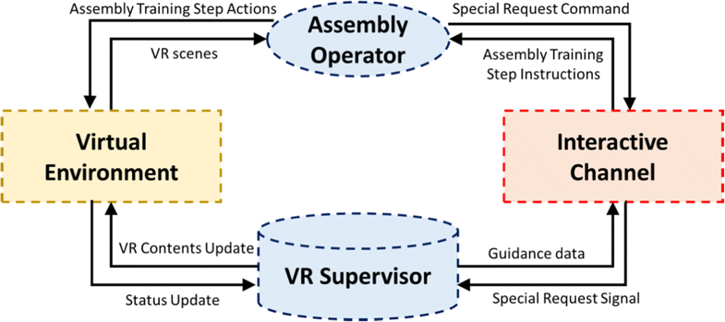](https://media.springernature.com/original/springer-static/image/art%3A10.1007%2Fs11042-018-6216-x/MediaObjects/11042_2018_6216_Fig1_HTML.png)](https://media.springernature.com/original/springer-static/image/art%3A10.1007%2Fs11042-018-6216-x/MediaObjects/11042_2018_6216_Fig1_HTML.png)

**Fig. 1**

Virtual Reality Assembly Guidance Training System (VRAGTS) Architecture

The learning process of the proposed training system is developed based on game concepts to introduce playfulness and fun, as these characteristics are proven to be related to efficient and effective learning [[33](https://link-springer-com.erl.lib.byu.edu/article/10.1007/s11042-018-6216-x#CR33)]. In order to cater for operators wholly new in the industry, the game-learning process of the proposed system is designed based on a step-by-step basis, allowing trainees to gradually acquire their skills and knowledge over time [[5](https://link-springer-com.erl.lib.byu.edu/article/10.1007/s11042-018-6216-x#CR5), [33](https://link-springer-com.erl.lib.byu.edu/article/10.1007/s11042-018-6216-x#CR33)]. Tutorial, practice and assessment phases are implemented to prepare trainees and/or test trainees if they are ready for the real-life tasks. The proposed training system can be used as an effective learning platform not only for new operators but also for existing operators who want to revise on the assembly steps [[33](https://link-springer-com.erl.lib.byu.edu/article/10.1007/s11042-018-6216-x#CR33), [56](https://link-springer-com.erl.lib.byu.edu/article/10.1007/s11042-018-6216-x#CR56)].

The game concept that will be integrated in the system’s learning process consists of three gaming stages. At the first stage, the trainees will undergo a tutorial lesson (*Tutorial No. 1*) to familiarize themselves with the materials, equipment, and other relevant supporting items that will be utilized during the assembly. After which, they will be tested and evaluated on this knowledge via a game assessment (*Assessment No. 1*). This ensures that operators, who are new in the industry, will at least acquire knowledge about the equipment/materials/supporting items required during the assembly. This ranges from the very basic of familiarizing with their terms to understanding their functions and purposes. At the second stage, the trainees will undergo the second tutorial lesson (*Tutorial No. 2*) to learn about the assembly step sequences. After the tutorial lesson, they will be tested and evaluated on this knowledge via a game assessment (*Assessment No. 2*). At the last stage (the most important stage in the game-learning process), the trainees will undergo the last tutorial lesson (*Tutorial No. 3*) that will demonstrate on how to perform the assembly steps. After the demonstration, they will be allowed to hands-on practise performing the assembly steps to build familiarity and confidence first before being tested and evaluated on this skill and knowledge via a game assessment (*Assessment No. 3*).

All tutorials, practices and assessments are operated within the virtual environment workspace under the VRAGTS. The trainees are required to pass each game assessment test based a minimum score requirement to move on to the next stage, else they are required to start their training from the beginning of the stage that they are currently in. At any point of time during any assessment test, the trainees can request for hints from the VR supervisor. However, they will be penalized for each hint request they make. The trainees will be deemed fit to proceed on to the real-life training phase by the system when they pass all the game assessment tests. The game-learning process overall flowchart of the proposed training system is summarized in Fig. [2](https://link-springer-com.erl.lib.byu.edu/article/10.1007/s11042-018-6216-x#Fig2).

[Open image in new window[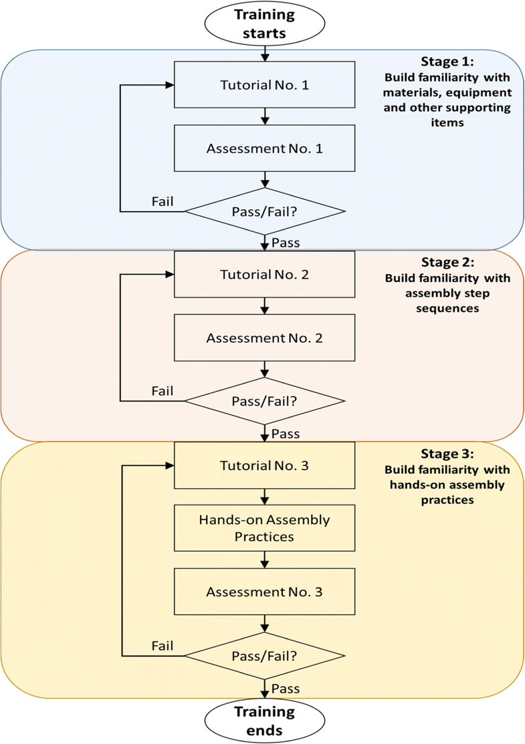](https://media.springernature.com/original/springer-static/image/art%3A10.1007%2Fs11042-018-6216-x/MediaObjects/11042_2018_6216_Fig2_HTML.png)](https://media.springernature.com/original/springer-static/image/art%3A10.1007%2Fs11042-018-6216-x/MediaObjects/11042_2018_6216_Fig2_HTML.png)

**Fig. 2**

Game-learning process overall flowchart of the VRAGTS

3.2 VR supervisor

The VR supervisor is an AI programme used to simulate a real human supervisor that is used to train/guide the trainee in the assembly training process. It is aware of any activities within the virtual workspace and will react accordingly in real-time. Its main functions are to: (a) decide and provide accurate, real-time guidance and training to the trainees via clear directions and instructions during the assembly training process, (b) detect and/or differentiate which training step the operator is at and if the steps are performed correctly, and (c) update VR contents in the virtual environment upon special request from the trainee [[5](https://link-springer-com.erl.lib.byu.edu/article/10.1007/s11042-018-6216-x#CR5)]. The motivation of utilizing this programme is to eliminate the need for any physical manager/supervisor, and significantly reduce the learning curve, training period and costs.

Figure [3](https://link-springer-com.erl.lib.byu.edu/article/10.1007/s11042-018-6216-x#Fig3) illustrates the summarized algorithm flowchart for the proposed VR training system. It also illustrates the VR supervisor’s involvement in each assembly training stage. When the assembly training stage starts, the VR supervisor will first give a tutorial to the trainee to learn about the relevant skills and/or knowledge required in the particular stage. After the tutorial, the practice/assessment starts (the assembly practice activity is only applicable for Stage 3 as mentioned in the previous section). During the practice/assessment activity, the VR supervisor will verify each assembly training step action taken by the trainee, and will provide the relevant training step instructions only if the trainee repeatedly performs wrong step actions (or in special cases, requests for hints). However, if the step action is correctly executed, the trainee will be allowed to continue on to the next training step and this cyclical process will continue until the practice/assessment task is completed. For Stage 3, the practice and assessment activities are the same except that the practice activity does not involve any evaluation process and the trainee is allowed to practise an unlimited number of times without getting any penalty. Lastly, for the assessment activity, the VR supervisor will determine whether the trainee has passed the test based on the scores obtained during the assessment and the passing mark criteria. If the trainee passes the assessment test, the trainee is allowed to continue to the next assembly training stage. This cyclical process will continue until the trainee passes the final assessment test (Stage 3), upon which the training will end.

[Open image in new window[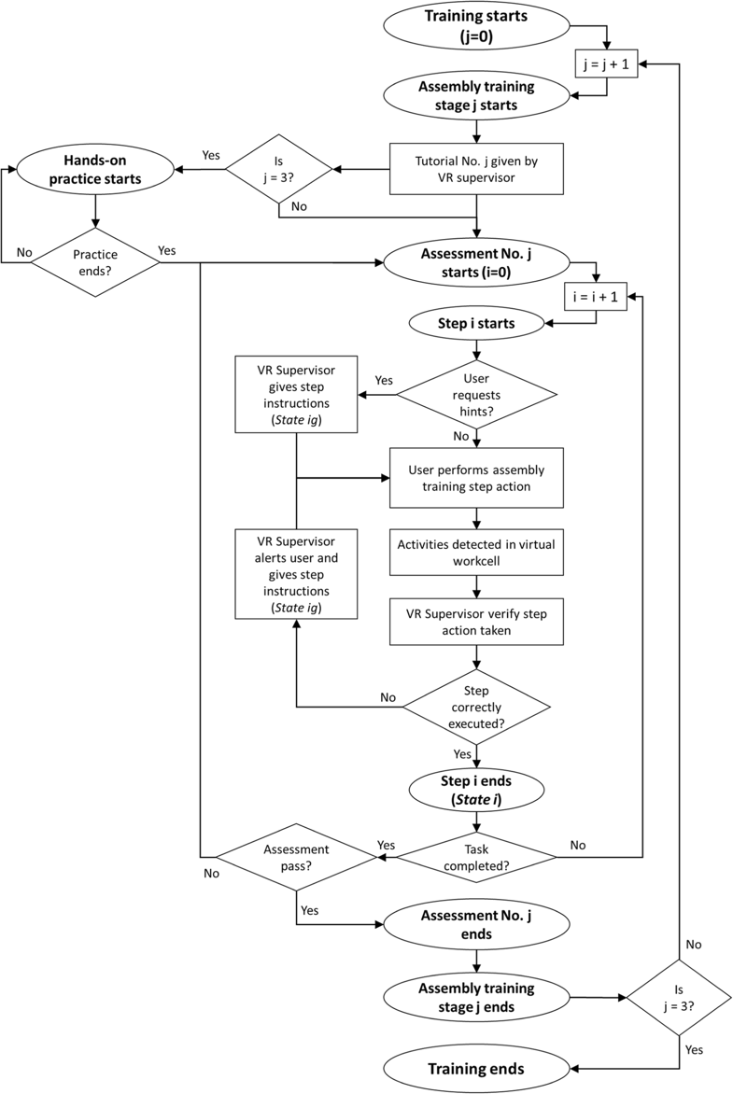](https://media.springernature.com/original/springer-static/image/art%3A10.1007%2Fs11042-018-6216-x/MediaObjects/11042_2018_6216_Fig3_HTML.png)](https://media.springernature.com/original/springer-static/image/art%3A10.1007%2Fs11042-018-6216-x/MediaObjects/11042_2018_6216_Fig3_HTML.png)

**Fig. 3**

Summarized algorithm flowchart: VR supervisor involvement

In order to integrate intelligence into the VR supervisor, a rule-based approach is considered as it had been successfully applied to interactive training processes within a virtual environment [[54](https://link-springer-com.erl.lib.byu.edu/article/10.1007/s11042-018-6216-x#CR54)]. The deterministic finite state machine concept, a type of rule-based system, is utilized to configure the VR supervisor. As a popular method to configure artificial intelligence (AI) for games, deterministic finite state machine is defined mathematically as a quintuple:

(I,Σ,δ,i0,iF)(I,Σ,δ,i0,iF)

(1)

Whereby *I* is a finite set of states (*I* = {*i*0, *i*1, ……, *iF*}), Σ is the input alphabet (a finite set of symbols), *δ* is the state transition function (*δ* : *I* × Σ → I), *i*0 is the initial state and *iF* is the final state [[28](https://link-springer-com.erl.lib.byu.edu/article/10.1007/s11042-018-6216-x#CR28)].

Figure [4](https://link-springer-com.erl.lib.byu.edu/article/10.1007/s11042-018-6216-x#Fig4) represents the VR supervisor finite state machine that is utilized during assembly practice or assessment activities, where guidance aids are most relevant. The motivation for this configuration is to enable the VR supervisor to effectively and efficiently make optimal decisions, to allow seamless state transitions based on the various transition conditions. For instance, when the trainee completes an assembly training step task (*Step i*), the VR supervisor will recognize that *Step i* is completed (*State i*) and that the trainee will be tackling the next step (*Step i + 1*). Hence, it will give the trainee instructions/directions for *Step i + 1* only if the trainee repeatedly performs wrong training step actions or requests hints while attempting to complete *Step i + 1*; this state is also known as *State (i + 1)g*.

[Open image in new window[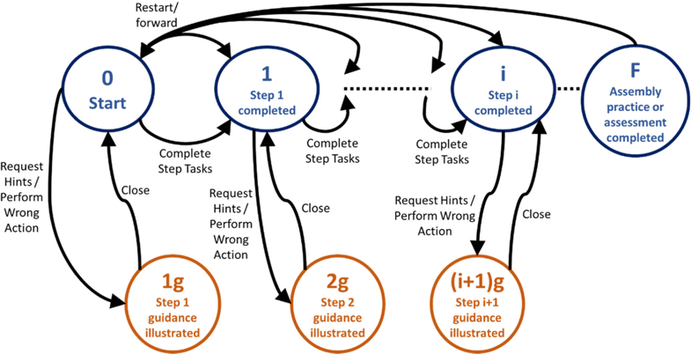](https://media.springernature.com/original/springer-static/image/art%3A10.1007%2Fs11042-018-6216-x/MediaObjects/11042_2018_6216_Fig4_HTML.png)](https://media.springernature.com/original/springer-static/image/art%3A10.1007%2Fs11042-018-6216-x/MediaObjects/11042_2018_6216_Fig4_HTML.png)

**Fig. 4**

VR supervisor finite state machine

3.3 Physics-based modelling and hand motion simulation model

The dynamic behaviours of the virtual objects (e.g. their motions and deformations) have to be characterized to enable users to perform motion-based HCI in the immersive virtual environment [[57](https://link-springer-com.erl.lib.byu.edu/article/10.1007/s11042-018-6216-x#CR57)]. There are many existing motion-based HCI techniques that can be considered and adopted in our VR training system. For instance, an articulated and generalized Gaussian kernel correlation (GKC)-based framework for human pose estimation was developed by Ding and Fan [[13](https://link-springer-com.erl.lib.byu.edu/article/10.1007/s11042-018-6216-x#CR13)]. The framework provided a continuous and differentiable similarity measure between a template and an observation, which were represented by various sum of Gaussians variants. An articulated Gaussian kernel correlation (AGKC) function was further developed by embedding a kinematic skeleton in a multivariate sum of Gaussians model. This new function supported subject-specific shape modelling and articulated pose estimation for the user’s body and hands. Lastly, by incorporating three regularization terms in the AGKC function (i.e. pose continuity, intersection penalty, visibility), a sequential pose tracking algorithm was developed. Based on benchmarking evaluations, the proposed algorithm was proven effective and efficient as compared to the state-of-the-art algorithms. In the work by Kılıboz and Güdükbay [[23](https://link-springer-com.erl.lib.byu.edu/article/10.1007/s11042-018-6216-x#CR23)], a method to recognize trajectory-based dynamic hand gestures in real time for HCI was proposed. A fast learning mechanism, which does not require much training data, was introduced to teach gestures to the system; the sample gesture data was filtered and processed to develop gesture recognizers. A six-degrees-of-freedom position tracker was also utilized to capture trajectory data. Gestures was represented as an ordered sequence of directional movements in two dimensions. The proposed method was proven to give users the freedom to develop gesture commands according to their personal preferences for chosen tasks. As such, the proposed hand gesture recognition technique made the HCI process more user specific and intuitive.

Physics modelling and hand motion simulation model are significant in VR training systems as they play an important role in the characterization of the virtual objects’ dynamic behaviours and the motion-based HCI. Moreover, they increase the accuracy of assembly performance evaluation and increase training task efficiency [[55](https://link-springer-com.erl.lib.byu.edu/article/10.1007/s11042-018-6216-x#CR55)]. We have utilized a mass-spring-damper model to characterize the dynamic behaviours of the virtual objects in the proposed system. These dynamic behaviours are governed by the geometries of the virtual objects and the external forces/torques that act upon them [[45](https://link-springer-com.erl.lib.byu.edu/article/10.1007/s11042-018-6216-x#CR45)]. The motivation of using the mass-spring-damper model for this purpose is to effectively tackle the issue of visual interpenetration, and allow whole-hand gripping and manipulation [[4](https://link-springer-com.erl.lib.byu.edu/article/10.1007/s11042-018-6216-x#CR4), [55](https://link-springer-com.erl.lib.byu.edu/article/10.1007/s11042-018-6216-x#CR55)]. According to Borst et al. [[4](https://link-springer-com.erl.lib.byu.edu/article/10.1007/s11042-018-6216-x#CR4)] and Xia et al. [[55](https://link-springer-com.erl.lib.byu.edu/article/10.1007/s11042-018-6216-x#CR55)], the model can be summarized using the following equations:

[M]x¨+[BT]x˙+[KT]x=F[M]x¨+[BT]x˙+[KT]x=F

(2)

[M]θ¨+[BR]θ˙+[KR]θ=T[M]θ¨+[BR]θ˙+[KR]θ=T

(3)

Whereby *F* and *T* are the external forces and torques applied to the virtual objects respectively, [*M*] is the mass matrix, [*BT*] and [*BR*] are the linear and torsional damping matrices respectively, [*KT*] and [*KR*] are the linear and torsional stiffness matrices respectively. x,¨x˙,xx,¨x˙,xare the acceleration, velocity and displacement vectors of the virtual objects respectively, while θ¨,θ˙,θθ¨,θ˙,θ are the angular acceleration, velocity and displacement vectors of the virtual objects respectively.

When two virtual objects are placed close enough to each other, a real-time computation based on the above physics model is carried out, and a geometry constraint is automatically captured. The precise assembly position is then calculated, leading to a generation of attractive or repulsive forces that naturally and realistically realize the assembly process.

There is also a need to create virtual hand movements in the virtual environment based on the user’s hand movements, so as to allow effective motion-based HCI between the user’s virtual hands and the virtual objects. The special computing sensory hardware needed to capture hand movement input and provide multimodal computer feedback is called an interface device [[49](https://link-springer-com.erl.lib.byu.edu/article/10.1007/s11042-018-6216-x#CR49)]. For the conducted experiments and evaluations in this paper, we utilize perception neuron sensors to provide multimodal recognition of hand movements, which enables us to simulate hand motions in the developed VR training system [[1](https://link-springer-com.erl.lib.byu.edu/article/10.1007/s11042-018-6216-x#CR1)]. The motivation behind this VR application is to create systematic human testing and training environments, which enable precise control of complex dynamic 3-D stimulus presentations, behavioural tracking, performance measurement, data recording, and analysis [[59](https://link-springer-com.erl.lib.byu.edu/article/10.1007/s11042-018-6216-x#CR59)]. The developed VR training system adopts the neuron sensor integrated system; the sensing mechanisms of the accelerometer and gyroscope sensors are illustrated in Fig. [5](https://link-springer-com.erl.lib.byu.edu/article/10.1007/s11042-018-6216-x#Fig5).

[Open image in new window[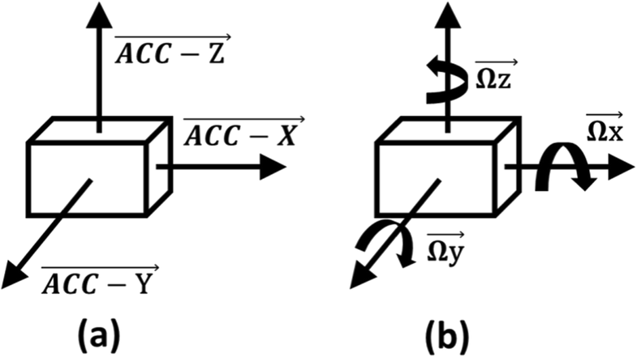](https://media.springernature.com/original/springer-static/image/art%3A10.1007%2Fs11042-018-6216-x/MediaObjects/11042_2018_6216_Fig5_HTML.png)](https://media.springernature.com/original/springer-static/image/art%3A10.1007%2Fs11042-018-6216-x/MediaObjects/11042_2018_6216_Fig5_HTML.png)

**Fig. 5**

Sensing mechanisms of **a** accelerometer for axis data measurements and **b** gyroscope for angular data measurements

The input measurements of the neuron sensor integrated system include three parts: (i) the translational position of the user’s hand using a 3-axis accelerometer, (ii) the rotational position of the user’s forearm using a 3-axis gyroscope, and (iii) the user’s hand gesture using a 3-axis magnetometer [[59](https://link-springer-com.erl.lib.byu.edu/article/10.1007/s11042-018-6216-x#CR59)]. These measured input data are transferred via a USB cable to a computer, where the input data are converted into weighted matrices. Based on these weighted matrices, the user’s hand motion will be simulated as virtual hand models in the VR training system. The structure diagram of the motion-based HCI system, which is utilized in the VR training system, is illustrated in Fig. [6](https://link-springer-com.erl.lib.byu.edu/article/10.1007/s11042-018-6216-x#Fig6) below.

[Open image in new window[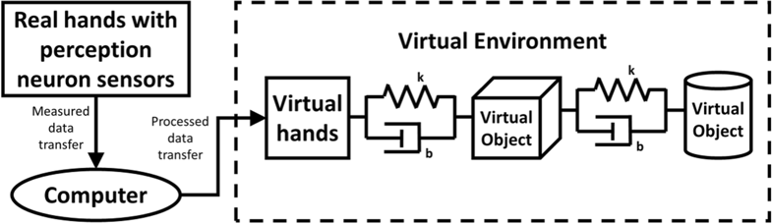](https://media.springernature.com/original/springer-static/image/art%3A10.1007%2Fs11042-018-6216-x/MediaObjects/11042_2018_6216_Fig6_HTML.png)](https://media.springernature.com/original/springer-static/image/art%3A10.1007%2Fs11042-018-6216-x/MediaObjects/11042_2018_6216_Fig6_HTML.png)

**Fig. 6**

Structure diagram of the motion-based HCI system

3.4 Utilized hardware and software

As our VR training system involves VR technology and perception neuron sensors, we have utilized a virtual reality head mounted display (HMD) and wearable sensors. Oculus Rift, a type of VR HMD, is utilized for rendering the developed virtual interactive environment to orchestrate the training process. The Oculus Rift comes with a sensor to position the headset in the space. As for the wearable sensors, we utilize Perception Neuron Lite, which is a product of NOITOM. This equipment, which is a set of six neuron sensors, is a sensor fusion of accelerometer, gyroscope and magnetometer sensors. This sensor fusion forms an inertial measurement unit (IMU). IMUs are commonly used in aircraft, UAVs, spacecraft, satellites and health care for measuring orientations, movements and positions [[10](https://link-springer-com.erl.lib.byu.edu/article/10.1007/s11042-018-6216-x#CR10)]. Perception Neuron Lite is useful in measuring the degrees of freedom of an object because of its sensor fusion mechanism [[39](https://link-springer-com.erl.lib.byu.edu/article/10.1007/s11042-018-6216-x#CR39)]. As such, it is able to accurately track hand motions in 3-D [[36](https://link-springer-com.erl.lib.byu.edu/article/10.1007/s11042-018-6216-x#CR36)]. We have attached the neuron sensors at the user’s arm, forehand, wrist, index finger, middle finger and thumb, with one sensor attached at each part. These sensors synchronize with one another to provide accurate and complete data of the user’s arm, hand and finger movements [[11](https://link-springer-com.erl.lib.byu.edu/article/10.1007/s11042-018-6216-x#CR11), [51](https://link-springer-com.erl.lib.byu.edu/article/10.1007/s11042-018-6216-x#CR51)].

As mentioned earlier, the gyroscope sensor is used in measuring the changes in rotational velocity; mainly for the rotational movement of the hand/arm part that it is attached to [[47](https://link-springer-com.erl.lib.byu.edu/article/10.1007/s11042-018-6216-x#CR47)]. The accelerometer sensors, on the other hand, are used to measure changes in velocities and positions of the user’s hands [[46](https://link-springer-com.erl.lib.byu.edu/article/10.1007/s11042-018-6216-x#CR46)]. A MEMS (Microelectromechanical systems) based accelerometer has been utilized because of its small size and ease of operation [[32](https://link-springer-com.erl.lib.byu.edu/article/10.1007/s11042-018-6216-x#CR32)]. Lastly, the magnetometer, which measures magnetism, helps in determining the absolute orientation of the user’s hands on the N-S-E-W plane [[51](https://link-springer-com.erl.lib.byu.edu/article/10.1007/s11042-018-6216-x#CR51)].

There are many software commercially available for developing virtual interactive environments. Commonly used software includes Unreal and Unity 3D. We have utilized Unity 3D for the development of the virtual interactive environment; Unity 3D is a game engine that supports 2D and 3D graphics, and C# and Java scripts. As for the modelling of the virtual objects, we have utilized Blender, which is a 3D computer graphics software tool. Blender is used to create the 3D virtual object models because it can easily convert these models into files that are compatible with the Unity software. Lastly, Axis Neuron, which is a support software for Perception Neuron Lite, is utilized to capture and broadcast motion data that are received by the individual sensors. These broadcasted data are utilized in the Unity software to simulate the motions of the user’s hand.

3.5 Overview of the proposed VR training system

In summary, the proposed VR training system utilizes a range of HCI techniques. Firstly, it utilizes a task-based HCI method that enables trainees to gradually acquire their skills and knowledge over time by learning on a step-by-step basis (i.e. from Stage 1 to Stage 3). The objectives at each stage are predetermined and established, and the trainees have to accomplish these objectives before they are allowed to move on to the next stage. Secondly, it utilizes a game-based HCI method that allows trainees to enjoy the training process with playfulness and fun through tutorials, assessments and/or practices at each stage. Thirdly, it introduces a motion-based HCI method that enables trainees to directly interact with the virtual objects using their simulated virtual hands (e.g. gripping, object manipulation). It also enables other virtual objects to interact with one another, and thus preventing visual interpenetration and enabling assembly operations to occur within the virtual environment. However, this method is only applicable at Stage 3, as only Stage 3 involves hands-on assembly practices and assessments. An overview flowchart of the proposed VR training system is illustrated in Fig. [7](https://link-springer-com.erl.lib.byu.edu/article/10.1007/s11042-018-6216-x#Fig7).

[Open image in new window[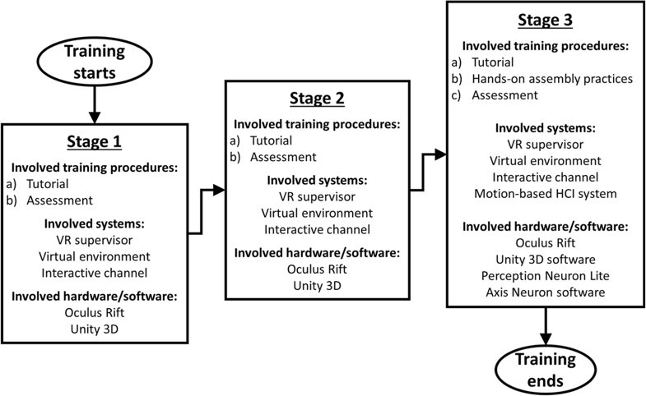](https://media.springernature.com/original/springer-static/image/art%3A10.1007%2Fs11042-018-6216-x/MediaObjects/11042_2018_6216_Fig7_HTML.png)](https://media.springernature.com/original/springer-static/image/art%3A10.1007%2Fs11042-018-6216-x/MediaObjects/11042_2018_6216_Fig7_HTML.png)

**Fig. 7**

Overview flowchart of the proposed VR training system

4 Assembly of hybrid medical device case study: artificial trachea

4.1 CNT-PDMS based artificial trachea prosthesis

We applied the concept of the proposed system framework to a practical approach based on recent research so as to prove its feasibility and effectiveness. We took reference to our previous work which involved the development of a patient-specific, CNT-PDMS (carbon nanotubes-polydimethylsiloxane) based artificial trachea prosthesis [[6](https://link-springer-com.erl.lib.byu.edu/article/10.1007/s11042-018-6216-x#CR6), [7](https://link-springer-com.erl.lib.byu.edu/article/10.1007/s11042-018-6216-x#CR7), [8](https://link-springer-com.erl.lib.byu.edu/article/10.1007/s11042-018-6216-x#CR8)]. Based on experiments done to replicate the fabrication of the CNT-PDMS based artificial trachea according to this reference, we have taken note of the following details/data: (a) the equipment, materials and supporting items required for this development summarized in Table [1](https://link-springer-com.erl.lib.byu.edu/article/10.1007/s11042-018-6216-x#Tab1), and (b) the assembly steps for the CNT-PDMS based artificial trachea prosthesis shown in Table [2](https://link-springer-com.erl.lib.byu.edu/article/10.1007/s11042-018-6216-x#Tab2). We shall utilize these known details/data to construct an appropriate virtual workcell.

**Table 1**

Equipment, materials and supporting items for CNT-PDMS based artificial trachea prosthesis

| **Equipment required** | **Materials required** | **Supporting items required** |
| --- | --- | --- |
| 1. Weighing scale | 1. PDMS pre-polymer | 1. Mold No. 1 (to assemble CNT-PDMS composite) |
| 2. Fume hood | 2. PDMS curing agent |
| 3. 2-in-1 oven (vacuum cum heat oven) | 2. Mold No. 2 (to assemble collagen coated prosthesis) |
| 4. Homogenizer | 3. Multi-Walled Carbon Nanotubes (MWCNT) |
| 5. Freeze drier | 3. Beaker |
| 6. Biosafety cabinet (BSC) | 4. Type I collagen sponge | 4. Pipette |
| 7. Cryopreservation system | 5. Disposable cup |
| 8. Water bath | 5. Harvested cryopreserved epithelial cells | 6. Stirrer/Spoon |
| 9. Bioreactor/incubator |

**Table 2**

Assembly steps for CNT-PDMS based artificial trachea prosthesis

| **Step no.** | **Assembly step description** |
| --- | --- |
| A) CNT-PDMS composite skeleton | |
| 1 | Pour PDMS pre-polymer into a beaker and add PDMS curing agent at 10:1 ratio using a pipette. |
| 2 | Put disposable cup on the weighing scale and tare it. Pour the PDMS mixture in the cup and take note of the weight. Using the spoon, add 0.2 to 1% mass of MWCNT to the mixture. |
| 3 | Bring the cup of mixture to the fume hood, switch on the fume hood, and stir the mixture thoroughly using the stirrer. |
| 4 | Put the cup of well-stirred mixture in the vacuum oven, switch it on, turn off gas intake, switch on vacuum suction pump, and leave the cup of mixture there for 1 h. After which, switch off the vacuum suction pump and then the vacuum oven. |
| 5 | Bring the cup of mixture to the fume hood. Slowly and carefully pour the vacuumed mixture into Mould No. 1. |
| 6 | Put mould of mixture in the oven, switch it on, and configure temperature and period settings. After 2 h of heating, allow material to cool for 15 mins. After which, remove mould from oven. |
| 7 | Bring the mould of mixture to the work bench and remove the cured CNT-PDMS composite from the mould. |
| B) CNT-PDMS composite with Type I collagen sponge | |
| 8 | Dissolve Type I collagen in aqueous hydrochloric acid in the fume hood. |
| 9 | Homogenize the solution at 8000 rpm for 15 min using the homogenizer in the fume hood. |
| 10 | Place the cured CNT-PDMS composite in the hollow region of Mould No. 2, and carefully pour the collagen mixture into the mould cavity. |
| 11 | Put mould of mixture in the freeze drier, configure temperature and period settings, and leave it for 2 h. |
| 12 | Transfer the mould of mixture to the vacuum oven, configure temperature and period settings, and leave it for 12 h. After which, remove mould from oven. |
| 13 | Bring the mould of mixture to the work bench and remove the composite from the mould. |
| 14 | Spray the composite with 70% ethanol, and place the composite in the BSC. Close the glass door and switch on the UV light for 1 h to sterilize it. |
| C) Complete Trachea Prosthesis | |
| 15 | Remove the cryopreserved epithelial cells from the cryopreservation system. |
| 16 | Thaw the cryopreserved epithelial cells in the water bath |
| 17 | Seed the thawed epithelial cells onto the composite using a pipette in the BSC. |
| 18 | Transfer the seeded composite to the bioreactor/incubator. |
| 19 | Allow the epithelial cells to grow and form a substantial amount of cilia. |

4.2 Virtual workcell for CNT-PDMS based artificial trachea prosthesis assembly

Figure [8](https://link-springer-com.erl.lib.byu.edu/article/10.1007/s11042-018-6216-x#Fig8) illustrates an overview of the virtual workcell that is designed and developed for CNT-PDMS based artificial trachea prosthesis assembly. The virtual workcell is constructed using the software UNITY 3D, considering the proposed system framework, basic physics-based modelling (e.g. collision detection, object manipulations) and relevant assembly steps. It is a platform that houses all virtual training activities (i.e. tutorials, practices and assessments), interactions between operator and the virtual items (i.e. equipment/materials/supporting items), and interactions between the operator and the VR supervisor. Referring to Fig. [9](https://link-springer-com.erl.lib.byu.edu/article/10.1007/s11042-018-6216-x#Fig9), upon entering *Activation* Mode when the training commences, the trainee is placed within the virtual workcell with the provided equipment, materials and supporting items. The trainee can interact with these virtual components using the virtual hands. The operator-to-VR supervisor interactive channel, in the form of virtual buttons, is placed on the top left corner of the trainee’s screen. This allows the trainee to conveniently send out special request commands (i.e. request for hints, restart, fast forward time) if needed.

[Open image in new window[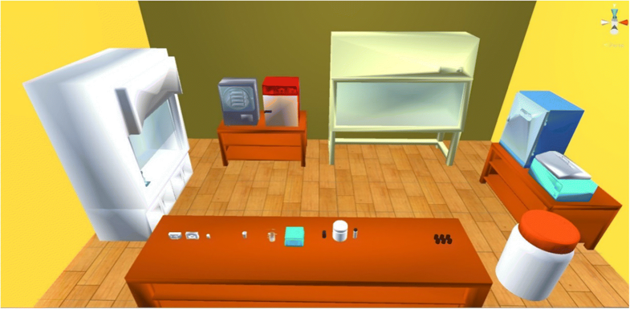](https://media.springernature.com/original/springer-static/image/art%3A10.1007%2Fs11042-018-6216-x/MediaObjects/11042_2018_6216_Fig8_HTML.png)](https://media.springernature.com/original/springer-static/image/art%3A10.1007%2Fs11042-018-6216-x/MediaObjects/11042_2018_6216_Fig8_HTML.png)

**Fig. 8**

An overview of the developed virtual workcell

[Open image in new window[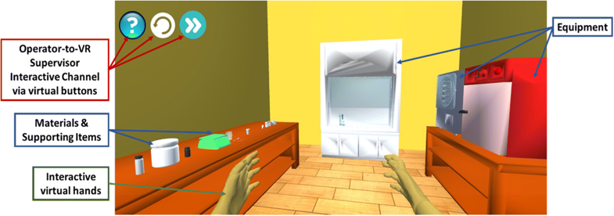](https://media.springernature.com/original/springer-static/image/art%3A10.1007%2Fs11042-018-6216-x/MediaObjects/11042_2018_6216_Fig9_HTML.png)](https://media.springernature.com/original/springer-static/image/art%3A10.1007%2Fs11042-018-6216-x/MediaObjects/11042_2018_6216_Fig9_HTML.png)

**Fig. 9**

The virtual workcell during activation mode

4.3 VR assembly guidance training (stage 1 and 2)

As mentioned in Section [2.1](https://link-springer-com.erl.lib.byu.edu/article/10.1007/s11042-018-6216-x#Sec5) earlier (Fig. [2](https://link-springer-com.erl.lib.byu.edu/article/10.1007/s11042-018-6216-x#Fig2)), the VR supervisor first exposes the trainees with Stage 1 and 2 of the game-learning process in order to build their familiarity with the involved equipment/materials/supporting items and with the assembly step sequence respectively. As illustrated in Figs. [10](https://link-springer-com.erl.lib.byu.edu/article/10.1007/s11042-018-6216-x#Fig10) and [11](https://link-springer-com.erl.lib.byu.edu/article/10.1007/s11042-018-6216-x#Fig11), during Tutorial No. 1 in Stage 1, the trainee is allowed to find out more about each equipment/materials/supporting item by just browsing around the virtual workcell. When the trainee stops and focuses at any relevant virtual item, details of the selected item will be presented to the trainee (e.g. its real image(s), its parts, and its purpose). This allows the trainee (especially a new one who has no prior knowledge/experience) to not only understand how the item looks like in reality, but also to understand its importance and role in the assembly process.

[Open image in new window[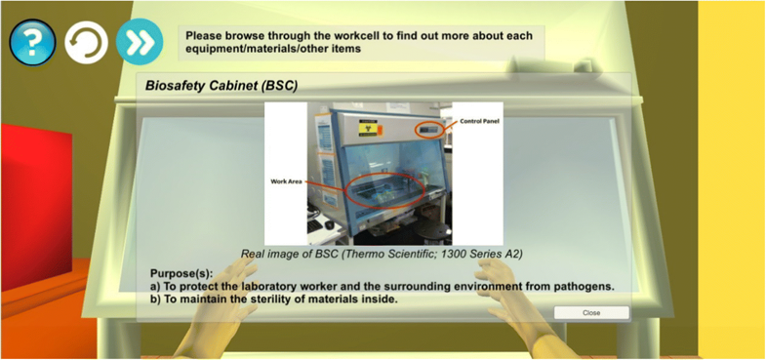](https://media.springernature.com/original/springer-static/image/art%3A10.1007%2Fs11042-018-6216-x/MediaObjects/11042_2018_6216_Fig10_HTML.png)](https://media.springernature.com/original/springer-static/image/art%3A10.1007%2Fs11042-018-6216-x/MediaObjects/11042_2018_6216_Fig10_HTML.png)

**Fig. 10**

Illustration of details of the BSC provided to the trainee for stage 1’s tutorial no. 1

[Open image in new window[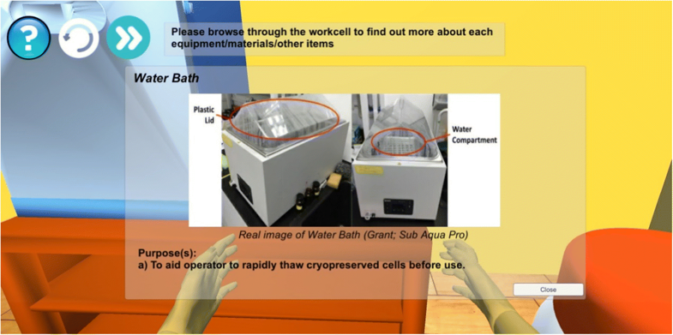](https://media.springernature.com/original/springer-static/image/art%3A10.1007%2Fs11042-018-6216-x/MediaObjects/11042_2018_6216_Fig11_HTML.png)](https://media.springernature.com/original/springer-static/image/art%3A10.1007%2Fs11042-018-6216-x/MediaObjects/11042_2018_6216_Fig11_HTML.png)

**Fig. 11**

Illustration of details of the water bath provided to the trainee for stage 1’s tutorial no. 1

On the other hand, during Tutorial No. 2 in Stage 2, the trainee is not allowed to browse around the virtual workcell freely while being exposed to the assembly step sequence. Instead, the VR supervisor gives the trainee a tour around the virtual workcell according to the step sequence. For instance, when Tutorial No. 2 commences, the trainee is stationed in front of the workbench because the first two assembly steps involve it and the items on it. Details of the relevant assembly steps will then be presented to the trainee as illustrated in Fig. [12](https://link-springer-com.erl.lib.byu.edu/article/10.1007/s11042-018-6216-x#Fig12). Upon clicking next, the trainee will be directed to be stationed in front of the fume hood where details of the third assembly step will be presented to him/her as illustrated in Fig. [13](https://link-springer-com.erl.lib.byu.edu/article/10.1007/s11042-018-6216-x#Fig13). This helps the trainee to not only familiarize with the step details, but also to remember the involvement of the relevant items for each step (e.g. Step 1 and 2 involves the workbench and Step 3 involves the fume hood as illustrated in Figs. [12](https://link-springer-com.erl.lib.byu.edu/article/10.1007/s11042-018-6216-x#Fig12) and [13](https://link-springer-com.erl.lib.byu.edu/article/10.1007/s11042-018-6216-x#Fig13)).

[Open image in new window[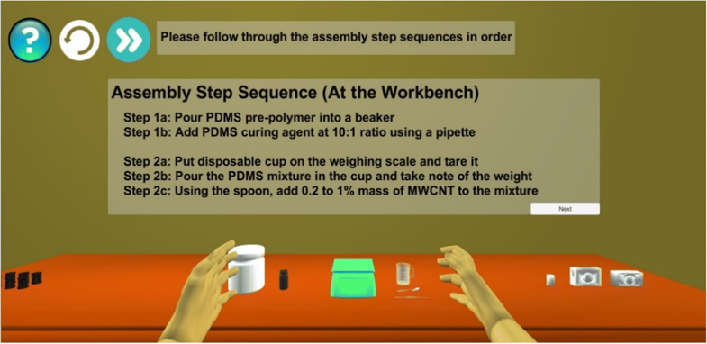](https://media.springernature.com/original/springer-static/image/art%3A10.1007%2Fs11042-018-6216-x/MediaObjects/11042_2018_6216_Fig12_HTML.png)](https://media.springernature.com/original/springer-static/image/art%3A10.1007%2Fs11042-018-6216-x/MediaObjects/11042_2018_6216_Fig12_HTML.png)

**Fig. 12**

Illustration of details of step 1 and 2 provided to the trainee at the workbench for stage 2’s tutorial no. 2

[Open image in new window[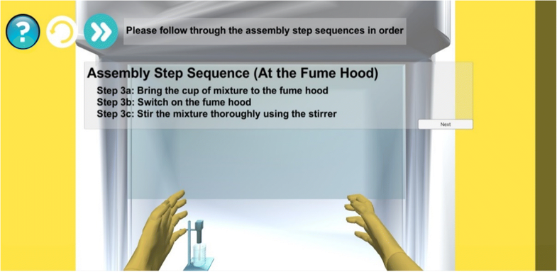](https://media.springernature.com/original/springer-static/image/art%3A10.1007%2Fs11042-018-6216-x/MediaObjects/11042_2018_6216_Fig13_HTML.png)](https://media.springernature.com/original/springer-static/image/art%3A10.1007%2Fs11042-018-6216-x/MediaObjects/11042_2018_6216_Fig13_HTML.png)

**Fig. 13**

Illustration of details of step 3 provided to the trainee at the fume hood for stage 2’s tutorial no. 2

4.4 VR assembly guidance training (stage 3)

As mentioned in Section [2.2](https://link-springer-com.erl.lib.byu.edu/article/10.1007/s11042-018-6216-x#Sec6) earlier, the VR supervisor is the key to provide an effective and efficient VR assembly guidance training. When the trainee presses on the “Request Hints” virtual button or repeatedly performs any wrong step action, the VR supervisor will provide relevant assembly training step guidance. In order to promote effective learning, the VR supervisor is programmed to give out the hints in a relevant and orderly manner. This prevents “spoon-feeding” the trainees as giving them the hints bit by bit instead of giving them the full guidance instructions all at once, allows them to explore and think critically on how to execute the assembly training step actions.

The first-level hint, consisting of only word instructions, is provided only at the first hint request or after a fixed number of repeated mistakes; these word instructions are passed to the trainee via the VR supervisor-to-Operator interactive channel, in form of a virtual panel. Next, the second-level hint (at second hint request or after a fixed number of repeated mistakes) consists of not only word instructions, but also visual directions to the relevant items involved in the training step. Lastly, the third-level hint (at third hint request or after a fixed number of repeated mistakes) consists of both word instructions and virtual animations of the required assembly training step action; this hint will be the same as what is presented in *Tutorial No. 3*. Figures [14](https://link-springer-com.erl.lib.byu.edu/article/10.1007/s11042-018-6216-x#Fig14), [15](https://link-springer-com.erl.lib.byu.edu/article/10.1007/s11042-018-6216-x#Fig15) and [16](https://link-springer-com.erl.lib.byu.edu/article/10.1007/s11042-018-6216-x#Fig16) illustrate how the VR supervisor guides the trainee during the assembly training (for Stage 3 Practice/ Assessment) for first-level, second-level and third-level hint respectively.

[Open image in new window[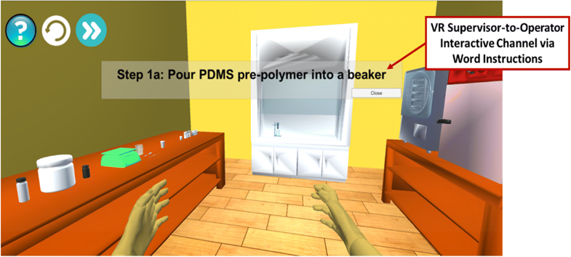](https://media.springernature.com/original/springer-static/image/art%3A10.1007%2Fs11042-018-6216-x/MediaObjects/11042_2018_6216_Fig14_HTML.png)](https://media.springernature.com/original/springer-static/image/art%3A10.1007%2Fs11042-018-6216-x/MediaObjects/11042_2018_6216_Fig14_HTML.png)

**Fig. 14**

Illustration of the VR assembly guidance via word instructions (first-level hint)

[Open image in new window[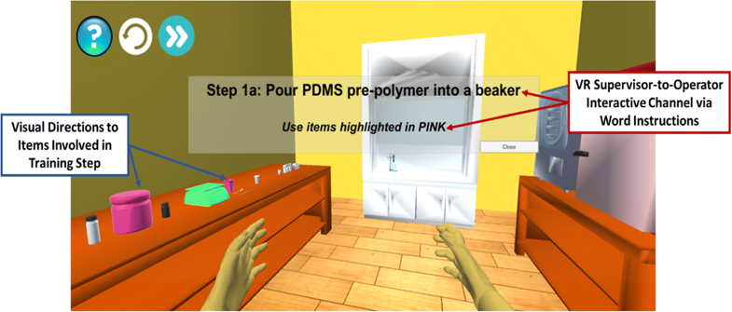](https://media.springernature.com/original/springer-static/image/art%3A10.1007%2Fs11042-018-6216-x/MediaObjects/11042_2018_6216_Fig15_HTML.png)](https://media.springernature.com/original/springer-static/image/art%3A10.1007%2Fs11042-018-6216-x/MediaObjects/11042_2018_6216_Fig15_HTML.png)

**Fig. 15**

Illustration of the VR assembly guidance via word instructions and visual directions (second-level hint)

[Open image in new window[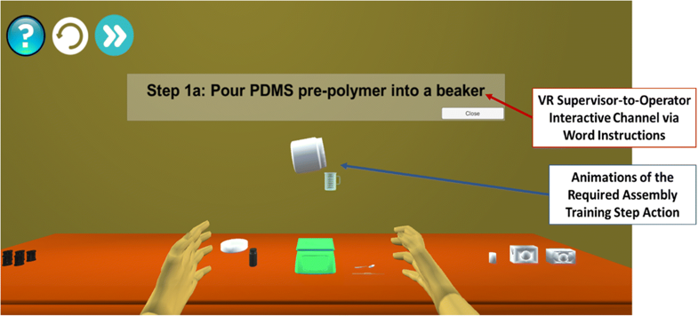](https://media.springernature.com/original/springer-static/image/art%3A10.1007%2Fs11042-018-6216-x/MediaObjects/11042_2018_6216_Fig16_HTML.png)](https://media.springernature.com/original/springer-static/image/art%3A10.1007%2Fs11042-018-6216-x/MediaObjects/11042_2018_6216_Fig16_HTML.png)

**Fig. 16**

Illustration of the VR assembly guidance via word instructions and virtual animations (third-level hint)

5 Evaluation of the proposed system

5.1 Evaluation objectives and settings

We have conducted an evaluation experiment (Evaluation No. 1) to compare the proposed VR training method (Method A) with a common VR training method (Method B) and a conventional physical training method (Method C). The experimental group comprised of a total of 30 participants, who have no prior skill or knowledge to the given application (i.e. hybrid medical device assembly). The participants were divided into three groups of 10 (Group A, Group B, and Group C), with the groups assigned respectively to try out the three training methods. The aim of this experiment is to prove the effectiveness and efficiency of Method A. This is achieved by comparing among the various training methods, the average training time taken and assessment scores obtained by the participants. Besides these quantitative data analyses, a survey using questionnaire (Questionnaire No. 1) was also conducted to compare qualitative metrics (e.g. effectiveness, confidence level, enjoyment level) among the various training methods, based on the participants’ opinions.

The experimental procedures for the evaluation of Method A involve three training stages, as mentioned earlier in Section [3.1](https://link-springer-com.erl.lib.byu.edu/article/10.1007/s11042-018-6216-x#Sec9). The participants, who are involved in this method (Group A), are required to undergo VR tutorials and assessments in Stage 1 and 2, and VR tutorial, practices and assessment in Stage 3. In other words, they undergo a wholly VR training experience and do not require any human assistance during the training process. As for Method B, its participants (Group B) are required to undergo a physical tutorial first, followed by VR practices and assessment during the training process. Unlike Group A, Group B’s participants undergo a partial VR training experience. Lastly, for Method C, its participants (Group C) are required to undergo one round each of physical tutorial, interview and assessment. In this case, Group C’s participants undergo a wholly physical training experience as there is no VR training involved. In order to enable a fair analysis of the obtained assessment scores among the various training methods, the same tutorial content and assessment questions are used during the evaluation process for each method.

We have also conducted another evaluation experiment (Evaluation No. 2) to compare qualitative metrics among various VR immersion techniques that can be applicable to the proposed VR training system. These qualitative metrics include the level of immersion in the virtual environment, the amount of control of the virtual objects, how realistic the system is, the level of comfort during training, the level of enjoyment during the training, and the potential of the technique for the development of an effective VR training system [[24](https://link-springer-com.erl.lib.byu.edu/article/10.1007/s11042-018-6216-x#CR24)]. Selected VR immersion techniques that are involved in this evaluation process include a HMD with neuron sensors (attached to right hand and arm only), a HMD with leap motion, a HMD with remote, a desktop PC with monitor display and mouse, and an Android tablet with touch screen display. The aim of this experiment is to analyse and compare the advantages and disadvantages of each VR immersion technique, in order to determine which technique(s) can potentially contribute to the development of an effective VR training system. The 20 participants that are involved in the VR-related training methods (Method A and B) are required to try out the various VR immersion techniques. A survey using questionnaire (Questionnaire No. 2) was also conducted to obtain subjective responses of these participants with regard to their VR training experiences for each VR immersion technique. A summary of the entire evaluation process is illustrated in Fig. [17](https://link-springer-com.erl.lib.byu.edu/article/10.1007/s11042-018-6216-x#Fig17).

[Open image in new window[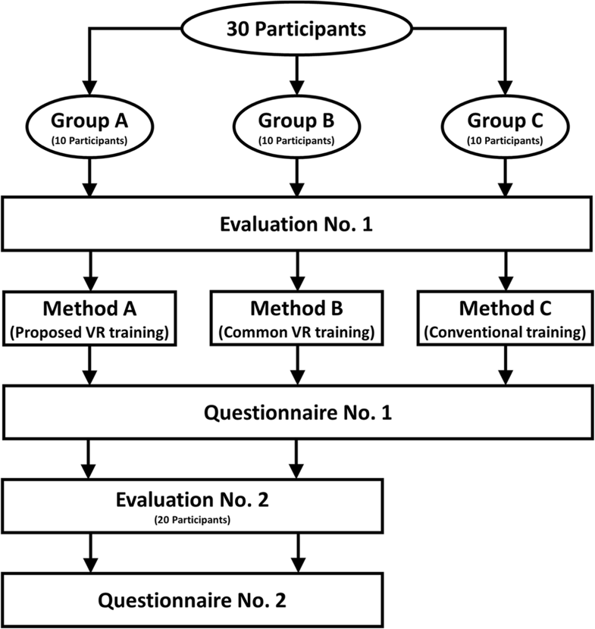](https://media.springernature.com/original/springer-static/image/art%3A10.1007%2Fs11042-018-6216-x/MediaObjects/11042_2018_6216_Fig17_HTML.png)](https://media.springernature.com/original/springer-static/image/art%3A10.1007%2Fs11042-018-6216-x/MediaObjects/11042_2018_6216_Fig17_HTML.png)

**Fig. 17**

A summary of the entire evaluation process

5.2 Evaluation results – comparison among various training methods

The effectiveness and efficiency of the various training methods are evaluated using quantitative data (i.e. the average training time taken and assessment scores obtained by the participants). Figures [18](https://link-springer-com.erl.lib.byu.edu/article/10.1007/s11042-018-6216-x#Fig18) and [19](https://link-springer-com.erl.lib.byu.edu/article/10.1007/s11042-018-6216-x#Fig19) summarize the comparisons, among the various methods, of the average training time taken and the average assessment scores obtained by the participants respectively.

[Open image in new window[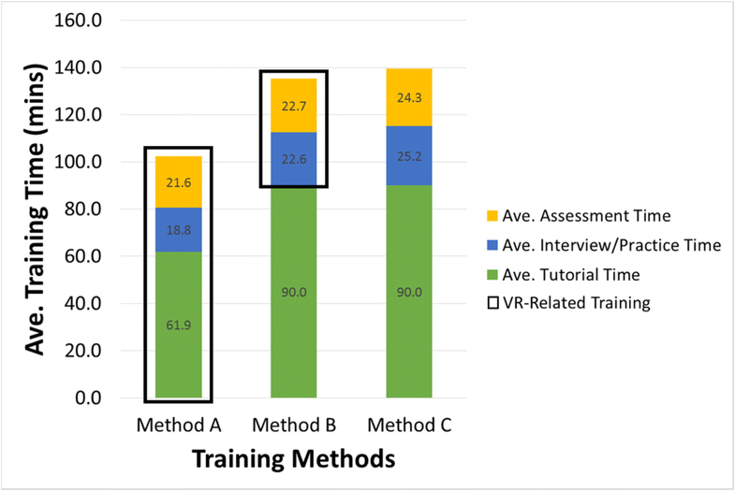](https://media.springernature.com/original/springer-static/image/art%3A10.1007%2Fs11042-018-6216-x/MediaObjects/11042_2018_6216_Fig18_HTML.png)](https://media.springernature.com/original/springer-static/image/art%3A10.1007%2Fs11042-018-6216-x/MediaObjects/11042_2018_6216_Fig18_HTML.png)

**Fig. 18**

Comparison of average training time among the various training methods

[Open image in new window[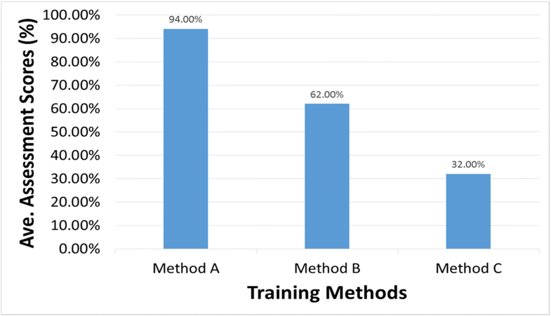](https://media.springernature.com/original/springer-static/image/art%3A10.1007%2Fs11042-018-6216-x/MediaObjects/11042_2018_6216_Fig19_HTML.png)](https://media.springernature.com/original/springer-static/image/art%3A10.1007%2Fs11042-018-6216-x/MediaObjects/11042_2018_6216_Fig19_HTML.png)

**Fig. 19**

Comparison of average assessment scores among the various training methods

Referring to Fig. [18](https://link-springer-com.erl.lib.byu.edu/article/10.1007/s11042-018-6216-x#Fig18), we can observe that the average training time taken per participant is the lowest for Method A, followed by Method B, and then Method C. The reductions in the average training time for Method A are 24.4 and 26.7% when compared to Method B and C respectively. Figure [18](https://link-springer-com.erl.lib.byu.edu/article/10.1007/s11042-018-6216-x#Fig18) also shows that for each training stage (i.e. tutorial, interview/practice, assessment), the average time taken per participant is lower for Method A than Method B and C. An interesting observation to note is that the average time taken per participant during the tutorial stage is significantly lower for Method A (61.9 mins) than Method B and C (90 mins) with a reduction of 31.2%. The reason for this phenomenon is that Method A focuses on VR tutorial, whereby individual participants who learn faster can proceed on to the next training stage. On the other hand, Method B and C focus on physical tutorial, whereby the participants attend the tutorial in a classroom setting and they are required to stay until the lesson and Q&A sessions are over. The last observation to note is that though the average training time taken per participant is lower for Method B as compared to Method C, the time reduction of 3% is not significant. A possible explanation for this could be that Method B’s VR system does not significantly reduce the amount of interview/practice and assessment times, having time reductions of only 10.3 and 6.6% respectively. This questions the effectiveness and efficiency of Method B’s one-stage VR training. On the other hand, when comparing the interview/practice and assessment times for Method A to those of Method C, the time reductions for these training stages are more significant (25.4 and 11.1% respectively).

Referring to Fig. [19](https://link-springer-com.erl.lib.byu.edu/article/10.1007/s11042-018-6216-x#Fig19), we can observe that the average assessment score per participant is the highest for Method A, followed by Method B, and then Method C. The average assessment score for Method A is 32.0 and 62.0% higher than Method B and C’s scores respectively. While the proposed VR training system (Method A) focuses on a sequential framework that enhances training through its various “game” levels of familiarity-building processes, the common VR training system (Method B) only focuses on one-stage VR training and the conventional training system (Method C) does not focus on any VR-related training. This set of results therefore proves the effectiveness of Method A’s VR system to train new users, as compared to Method B and C.

The effectiveness of the various training methods are further evaluated and analysed using the qualitative ratings based on the participants’ subjective responses. Figure [20](https://link-springer-com.erl.lib.byu.edu/article/10.1007/s11042-018-6216-x#Fig20) summarizes the comparisons of the average ratings for the different qualitative metrics (i.e. effectiveness, confidence, enjoyment, comfort) among the various training methods. Referring to Fig. [20](https://link-springer-com.erl.lib.byu.edu/article/10.1007/s11042-018-6216-x#Fig20), we can observe that for every qualitative metric, the average ratings per participant is the highest for Method A, followed by Method B, and then Method C.

[Open image in new window[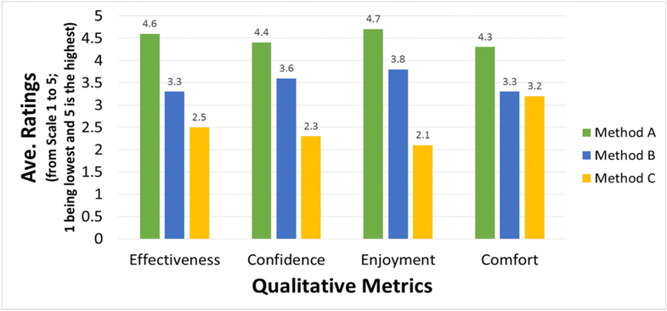](https://media.springernature.com/original/springer-static/image/art%3A10.1007%2Fs11042-018-6216-x/MediaObjects/11042_2018_6216_Fig20_HTML.png)](https://media.springernature.com/original/springer-static/image/art%3A10.1007%2Fs11042-018-6216-x/MediaObjects/11042_2018_6216_Fig20_HTML.png)

**Fig. 20**

Comparison of average ratings for the different qualitative metrics among the various training methods

Firstly, Method A’s participants on average felt that the proposed VR training system was very effective, Method B’s participants on average felt that the common VR training system was moderately effective, and Method C’s participants on average felt that the conventional training system was not effective. These results are expected due to the multi-stage VR training from Method A, one-stage VR training from Method B, and no VR-related training from Method C as mentioned earlier in the quantitative analysis.

Secondly, Method A’s participants on average felt that the proposed VR training system significantly boosted their level of confidence in handling the assembly tasks, Method B’s participants on average felt that the common VR training system fairly increased their level of confidence, and Method C’s participants on average felt that the conventional training system poorly increased their level of confidence. These results are further evaluated by comparing the readiness level of the participants among the various training methods as summarized in Fig. [21](https://link-springer-com.erl.lib.byu.edu/article/10.1007/s11042-018-6216-x#Fig21). Referring to Fig. [21](https://link-springer-com.erl.lib.byu.edu/article/10.1007/s11042-018-6216-x#Fig21), it can be observed that 90% of Method A’s participants felt ready to proceed to the next training level (i.e. physical training in the lab), whereas only 40% of Method B’s participants and 30% of Method C’s participants felt ready.

[Open image in new window[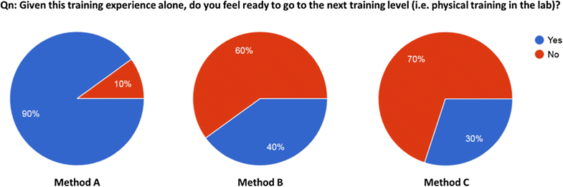](https://media.springernature.com/original/springer-static/image/art%3A10.1007%2Fs11042-018-6216-x/MediaObjects/11042_2018_6216_Fig21_HTML.png)](https://media.springernature.com/original/springer-static/image/art%3A10.1007%2Fs11042-018-6216-x/MediaObjects/11042_2018_6216_Fig21_HTML.png)

**Fig. 21**

Comparison of readiness level of participants among the various training methods

Thirdly, Method A’s participants on average felt that the proposed VR training system was significantly enjoyable, Method B’s participants on average felt that the common VR training system was moderately enjoyable, and Method C’s participants on average felt that the conventional training system was not enjoyable. Based on these results, we deduced that the level of enjoyment stems from the amount of VR involvement in the training system, and thus explaining the low average rating for Method C and higher average ratings for Method A and B. The higher average rating for Method A as compared to Method B could be due to the longer exposure in the VR system for Method A as illustrated earlier in Fig. [18](https://link-springer-com.erl.lib.byu.edu/article/10.1007/s11042-018-6216-x#Fig18).

Lastly, Method A’s participants on average felt that the proposed VR training system was very comfortable, whereas Method B and C’s participants on average felt that the respective training systems were moderately comfortable. Based on these results, we deduced that the level of comfort is inversely related to the amount of time taken to conduct the physical tutorial. This explains the lower average ratings for Method B and C as compared to Method A, as Method A does not involve any physical tutorial whereas Method B and C involve physical tutorials. Moreover, the time taken to conduct the physical tutorials are the same for Method B and C, and thus explaining the almost similar average ratings for these two methods.

In summary, the quantitative comparisons among the various training methods have proved that the proposed VR training system (Method A) is more effective and efficient than the common VR training system (Method B) and the conventional training system (Method C). This is because of its lower average training time taken and higher average assessment scores obtained by its participants, as compared to Method B and C. The qualitative comparisons among the various training methods have further proved the superior effectiveness of Method A, as its average ratings are higher in every metric when compared to other methods.

5.3 Evaluation results – comparison among various VR immersion techniques

As mentioned earlier in Section [3.4](https://link-springer-com.erl.lib.byu.edu/article/10.1007/s11042-018-6216-x#Sec12), we have utilized HMD with neuron sensors to orchestrate the VR training processes for Evaluation No. 1. This section covers the analysis of the results that were obtained from Evaluation No. 2. For Evaluation No. 2, we have also considered other various VR immersion techniques (i.e. HMD with leap motion, HMD with remote, desktop PC with monitor display and mouse, Android tablet with touch screen display) that can be applicable to the proposed VR training system. The effectiveness of the various VR immersion techniques are evaluated and analysed using qualitative ratings based on the participants’ subjective responses. Figure [22](https://link-springer-com.erl.lib.byu.edu/article/10.1007/s11042-018-6216-x#Fig22) summarizes the comparisons of the average ratings for the different qualitative metrics among the various VR immersion techniques. Figure [23](https://link-springer-com.erl.lib.byu.edu/article/10.1007/s11042-018-6216-x#Fig23), on the other hand, illustrates the various VR immersion techniques that are evaluated for Evaluation No. 2.

[Open image in new window[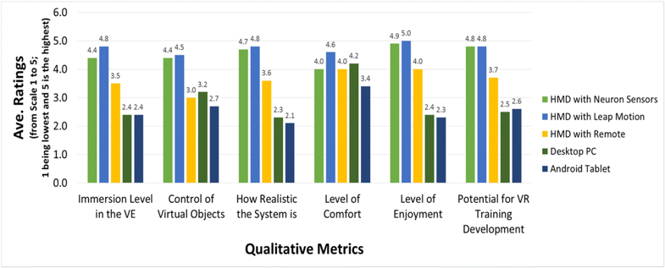](https://media.springernature.com/original/springer-static/image/art%3A10.1007%2Fs11042-018-6216-x/MediaObjects/11042_2018_6216_Fig22_HTML.png)](https://media.springernature.com/original/springer-static/image/art%3A10.1007%2Fs11042-018-6216-x/MediaObjects/11042_2018_6216_Fig22_HTML.png)

**Fig. 22**

Comparison of average ratings for the different qualitative metrics among the various vr immersion techniques

[Open image in new window[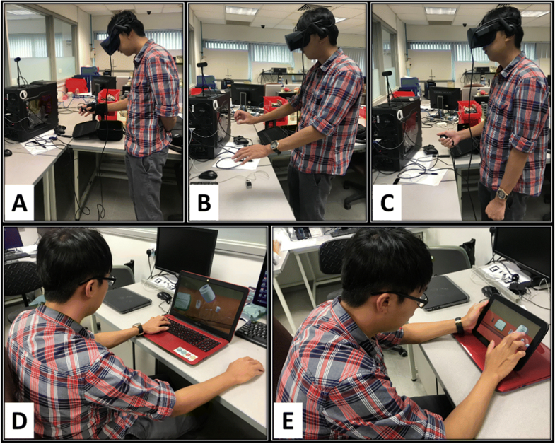](https://media.springernature.com/original/springer-static/image/art%3A10.1007%2Fs11042-018-6216-x/MediaObjects/11042_2018_6216_Fig23_HTML.png)](https://media.springernature.com/original/springer-static/image/art%3A10.1007%2Fs11042-018-6216-x/MediaObjects/11042_2018_6216_Fig23_HTML.png)

**Fig. 23**

Illustration of the various VR immersion techniques: **a** HMD with neuron sensors, **b**HMD with leap motion, **c** HMD with remote, **d** desktop PC with monitor display and mouse, and **e** android tablet with touch screen display

Referring to Fig. [22](https://link-springer-com.erl.lib.byu.edu/article/10.1007/s11042-018-6216-x#Fig22), we can observe that the participants on average felt most immersed in the virtual environment for the HMD with leap motion and the HMD with neuron sensors techniques, followed by the HMD with remote technique, and then the desktop PC and the Android tablet techniques. Some metrics are also rated in a similar order by the participants. These metrics include how realistic the technique is, the level of enjoyment during the training, and the potential of the technique to develop an effective VR training system. The reason for these phenomena is that the HMD-related techniques are able to allow the users to view the virtual environment in very close proximity, unlike the desktop PC and Android tablet techniques which only allow the users to view the virtual environment in a limited-size screen. Hence, this explains their higher immersion level, more realistic settings, higher enjoyment level and higher potential to develop an effective VR training system, as compared to the desktop PC and Android tablet techniques. In addition, considering these mentioned metrics, the reason for the higher average ratings for the HMD with leap motion and the HMD with neuron sensors techniques (as compared to other techniques) is because of their superior interaction ability. These two techniques are armed with supporting devices to match the virtual hand movements with the users’ hand movements, and thus allowing the users to directly interact with the virtual objects in a realistic manner. The other techniques, on the other hand, only allow the users to interact with the virtual objects using a virtual cursor via either a remote, a mouse, or a touch screen display, depending on what the technique is. Hence, this also explains why the participants on average felt that the HMD with leap motion and the HMD with neuron sensors techniques best allow them to control the virtual objects as compared to other techniques.

The participants on average felt the most comfortable when it comes to the HMD with leap motion technique, followed by the desktop PC technique, and then the HMD with neuron sensors and the HMD with remote techniques. The Android tablet technique is ranked last in terms of comfort. The reason why the HMD with leap motion and desktop PC techniques are ranked highest is because these techniques do not require the users to put on any wearables or to hold on to any device. This is unlike the HMD with neuron sensors, the HMD with remote and the Android tablet techniques, which respectively require the users to put on wearable sensors, to hold on to a remote, and to hold on to the Android tablet, hence explaining their lower average ratings.

In summary, the qualitative comparisons among the various VR immersion techniques have proved the effectiveness of the HMD with leap motion and the HMD with neuron sensors techniques. This is because of their higher average ratings in almost every metric when compared to other techniques. One interesting observation to note is that for almost every qualitative metric, the average rating per participant for the HMD with leap motion technique is slightly higher than the average rating for the HMD with neuron sensors technique. The reason for this phenomenon could be that the HMD with neuron sensors technique, which we have configured for this evaluation process, only takes into account six wearable neuron sensors that are placed at selected locations of the users’ the right arm/fingers as mentioned in Section [3.4](https://link-springer-com.erl.lib.byu.edu/article/10.1007/s11042-018-6216-x#Sec12). Hence, this may affect its effectiveness as this configuration does not fully immerse the users into the virtual environment. However, despite its lower average ratings as compared to the HMD with leap motion technique, we still believe in the superior potential of the HMD with neuron sensors technique as it can be upgraded to have more wearable sensors throughout the whole body (i.e. on both sides of the arm, fingers, legs, feet and body). This modified configuration will be able to fully immerse the users into the virtual environment, and thus significantly increasing its effectiveness.

6 Discussions and conclusion

As hybrid medical device fabrication involves manual assembly due to its complexity, skill training in this industry is essential to optimize and expedite the efficiency level of new assembly operators. The main contributions of this paper are that we (a) proposed and evaluated a novel VR training system (the VRAGTS) that addresses the underlying training issues for hybrid medical device assembly by providing trainees with effective, efficient, risk-free and low cost training, and (b) evaluated and analysed the effectiveness of the various VR immersion techniques that can be applicable to the proposed VR training system.

By incorporating concepts from AI, VR and gaming, the proposed system is self-adaptive and autonomous, and thus enabling the training to take place in a virtual workcell environment without the supervision of a physical trainer. It also utilizes a unique sequential framework that enhances training through its various “game” levels of familiarity-building processes. As such, the proposed system is able to promote real-time effective guidance, interaction and fun for trainees during the training process, and thus enabling easy transfer of skill/knowledge to the trainees. Moreover, in a VR environment, there will be no contamination/safety risks involved and physical equipment/materials/supporting items are not required, allowing significant cost savings to be reaped. With the help of the VR supervisor, the proposed system can also eliminate the need for any physical manager/supervisor, and significantly reduce the learning curve, training period and costs [[5](https://link-springer-com.erl.lib.byu.edu/article/10.1007/s11042-018-6216-x#CR5)].

The evaluation results of the proposed VR training system have proved these advantages over other training methods. If we were to compare the features among the various training methods, one can observe that the proposed system has a superior advantage in all aspects to the common VR training and the conventional training methods. Firstly, the higher average assessment scores obtained by its participants, as compared to other methods, have proved that the proposed VR training system is able to effectively transfer skills/knowledge to the users. On top of this, the qualitative comparisons among the various training methods have further proved the superior effectiveness of the proposed VR training system, as its participants on average felt that they can learn better due to high levels of confidence, enjoyment and comfort obtained during their training. Secondly, the lower average training time taken by its participants, as compared to other methods, have proved that the proposed VR training system is able to efficiently reduce the learning curve and training periods. Lastly, the proposed system is a wholly VR system and does not require any human assistance during the training process, and thus eliminating any costs that can be incurred from hiring a physical trainer. This is unlike the common VR training and the conventional training methods which still require physical trainers to conduct the training. The proven advantages of the proposed framework over other training methods have illustrated its potential to improve current training systems, specifically for complex assembly operations such as the fabrication of hybrid medical devices. The comparison of the features among the various training methods can be summarized in Table [3](https://link-springer-com.erl.lib.byu.edu/article/10.1007/s11042-018-6216-x#Tab3).

**Table 3**

Comparison of Features among various training methods

| **Metrics** | **Features** | **VRAGTS** | **Common VR training method** | **Conventional training method** |
| --- | --- | --- | --- | --- |
| Effectiveness | Transferability of skill/knowledge | ✓✓✓✓✓ | ✓✓✓ | X |
| Level of user confidence | ✓✓✓✓✓ | ✓✓✓ | X |
| Level of user enjoyment | ✓✓✓✓✓ | ✓✓✓ | X |
| Level of user comfort | ✓✓✓✓✓ | ✓✓✓ | X |
| Efficiency | Reduced learning curve | ✓✓✓✓✓ | ✓✓✓ | X |
| Reduced training period | ✓✓✓✓✓ | ✓✓✓ | X |
| Training cost savings | | ✓✓✓✓✓ | ✓✓✓ | X |
| No need for physical trainer | | ✓✓✓✓✓ | ✓✓✓ | X |

We have also evaluated and analysed the effectiveness of the various VR immersion techniques that can be applicable to the proposed VR training system. Based on our evaluation results, the most effective techniques are the HMD with leap motion and the HMD with neuron sensors techniques. The participants on average felt that these techniques enable them to (a) be deeply immersed in the virtual environment, (b) effectively control the virtual objects, (c) be in a very realistic setting, and (d) greatly enjoy the training process. As such, they acknowledge the high potential of these techniques to develop an effective VR training system. Comparing the level of comfort metric between these two techniques, the HMD with leap motion technique is rated as more comfortable than the HMD with neuron sensors technique. This is due to the requirement to put on wearable sensors for the latter technique, as compared to the former technique that does not require the users to put on any wearables or to hold on to any device. Another disadvantage that the HMD with neuron sensors technique has is that the current configuration of only six wearable neuron sensors on the right arm/fingers does not fully immerse the users into the virtual environment, and thus explaining its slightly lower effectiveness when compared to the HMD with leap motion technique. However, despite having these disadvantages, the HMD with neuron sensors technique can be further upgraded with increased number of wearable sensors throughout the whole body (i.e. on both sides of the arm, fingers, legs, feet and body). We believe in the superior potential of this modified configuration to fully immerse the users into the virtual environment, which will significantly increase its effectiveness. As such, the HMD with neuron sensors technique is the most suitable candidate to develop an effective VR system based on the proposed training method.

The proposed VR training system can also be used for other applications, apart from the mentioned hybrid medical device assembly training application. For instance, in the healthcare industry, the proposed system can be utilized to effectively train caregivers on how to use sophisticated sensors to track and analyse the Activities of Daily Living (ADL) of elderly people. This will enable the caregivers to provide the elderly people with proactive assistance, and thus allowing effective facilitation of their activity tracking and management [[29](https://link-springer-com.erl.lib.byu.edu/article/10.1007/s11042-018-6216-x#CR29), [30](https://link-springer-com.erl.lib.byu.edu/article/10.1007/s11042-018-6216-x#CR30)]. Another potential application will be rehabilitation training, whereby the proposed system can be utilized to effectively train patients to perform rehabilitation exercises [[3](https://link-springer-com.erl.lib.byu.edu/article/10.1007/s11042-018-6216-x#CR3), [29](https://link-springer-com.erl.lib.byu.edu/article/10.1007/s11042-018-6216-x#CR29), [43](https://link-springer-com.erl.lib.byu.edu/article/10.1007/s11042-018-6216-x#CR43)].

In order to develop a complete VR system for hybrid medical device assembly operations, we shall consider biology-based modelling on top of the currently implemented physics-based modelling for future work. We also intend to (a) upgrade the configuration of the HMD with neuron sensors technique to support more wearable sensors throughout the whole body, and (b) integrate more sophisticated and useful hardware aids like haptic feedback and force-sensors integrated gloves to enhance the effectiveness and user-experience of our proposed VR training system. We shall also consider applying video-based 3D human motion tracking technology to the proposed system [[12](https://link-springer-com.erl.lib.byu.edu/article/10.1007/s11042-018-6216-x#CR12)]. This method, which is based on a novel fusion formulation that integrates low- and high-dimensional tracking approaches into one framework, will enable us to effectively and efficiently track the user’s movements [[12](https://link-springer-com.erl.lib.byu.edu/article/10.1007/s11042-018-6216-x#CR12)], which can then be mapped to the virtual environment. Future work also includes further testing our VR training system on human subjects by applying subjective evaluations during the experiment. The evaluations conducted in this paper are objective-based, as they investigated the effectiveness and efficiency of the proposed system using operators who do not have any prior relevant knowledge and/or experiences of the assembly operation [[27](https://link-springer-com.erl.lib.byu.edu/article/10.1007/s11042-018-6216-x#CR27)]. For instance, comparing the time taken for them to successfully complete the tasks when using the proposed system to conventional methods [[20](https://link-springer-com.erl.lib.byu.edu/article/10.1007/s11042-018-6216-x#CR20)]. Subjective evaluations, on the other hand, will aim to investigate the acceptance and potential in value-adding elements of the proposed system from the perspective of experienced operators, trainers and managers who has the ability to compare the proposed system with the conventional training methods [[27](https://link-springer-com.erl.lib.byu.edu/article/10.1007/s11042-018-6216-x#CR27)].

Notes

Acknowledgements

We wish to acknowledge the contributions from Mr. Rahul Singh Chauhan, Mr. Jayendra Laxman Zambre and Mr. Ritesh Kumar Agrahari for their assistance in the development of the VR systems. This project is supported in parts by a MOE FRC Tier 1 Grant from National University of Singapore (WBS: R-265-000-614-114).

References

1. 1.

Alamri A, Eid M, Iglesias R, Shirmohammadi S, Saddik AE (2008) Haptic virtual rehabilitation exercises for post-stroke diagnosis. IEEE Trans Instrum Meas 57(9):1876–1884[CrossRef](https://doi-org.erl.lib.byu.edu/10.1109/TIM.2008.919878)[Google Scholar](http://scholar.google.com.erl.lib.byu.edu/scholar_lookup?title=Haptic%20virtual%20rehabilitation%20exercises%20for%20post-stroke%20diagnosis&author=A.%20Alamri&author=M.%20Eid&author=R.%20Iglesias&author=S.%20Shirmohammadi&author=AE.%20Saddik&journal=IEEE%20Trans%20Instrum%20Meas&volume=57&issue=9&pages=1876-1884&publication_year=2008)

1. 2.

Albert DE (2015) Methods for verifying medical device cleanliness. In: Developments in surface contamination and cleaning, volume 7: cleanliness validation and verification. Elsevier, Amsterdam, pp 109–128[CrossRef](https://doi-org.erl.lib.byu.edu/10.1016/B978-0-323-31303-2.00004-2)[Google Scholar](http://scholar.google.com.erl.lib.byu.edu/scholar_lookup?title=Methods%20for%20verifying%20medical%20device%20cleanliness&author=DE.%20Albert&pages=109-128&publication_year=2015)

1. 3.

Boian RF, Sharma AK, Han C, Merians AN, Burdea GC, Adamovich S, Recce ML, Tremaine M, Poizner H (2002) Virtual reality-based post-stroke hand rehabilitation. Stud Health Technol Inform 85(1):64–70[Google Scholar](http://scholar.google.com.erl.lib.byu.edu/scholar_lookup?title=Virtual%20reality-based%20post-stroke%20hand%20rehabilitation&author=RF.%20Boian&author=AK.%20Sharma&author=C.%20Han&author=AN.%20Merians&author=GC.%20Burdea&author=S.%20Adamovich&author=ML.%20Recce&author=M.%20Tremaine&author=H.%20Poizner&journal=Stud%20Health%20Technol%20Inform&volume=85&issue=1&pages=64-70&publication_year=2002)

1. 4.

Borst CW, Indugula AP (2006) A spring model for whole-hand virtual grasping. Presence-Teleop VIRT 15(1):47–61[CrossRef](https://doi-org.erl.lib.byu.edu/10.1162/pres.2006.15.1.47)[Google Scholar](http://scholar.google.com.erl.lib.byu.edu/scholar_lookup?title=A%20spring%20model%20for%20whole-hand%20virtual%20grasping&author=CW.%20Borst&author=AP.%20Indugula&journal=Presence-Teleop%20VIRT&volume=15&issue=1&pages=47-61&publication_year=2006)

1. 5.

Brough JE, Schwartz M, Gupta SK, Anand DK, Kavetsky R, Pettersen R (2007) Towards the development of a virtual environment-based training system for mechanical assembly operations. Virtual Reality 11(4):189–206[CrossRef](https://doi-org.erl.lib.byu.edu/10.1007/s10055-007-0076-4)[Google Scholar](http://scholar.google.com.erl.lib.byu.edu/scholar_lookup?title=Towards%20the%20development%20of%20a%20virtual%20environment-based%20training%20system%20for%20mechanical%20assembly%20operations&author=JE.%20Brough&author=M.%20Schwartz&author=SK.%20Gupta&author=DK.%20Anand&author=R.%20Kavetsky&author=R.%20Pettersen&journal=Virtual%20Reality&volume=11&issue=4&pages=189-206&publication_year=2007)

1. 6.

Chua M, Chui CK, Chng CB, Lau D (2013) Carbon nanotube-based artificial tracheal prosthesis: carbon nanocomposite implants for patient-specific ENT care. IEEE Nanotechnol Mag *7*(*4*):27–31[CrossRef](https://doi-org.erl.lib.byu.edu/10.1109/MNANO.2013.2289691)[Google Scholar](http://scholar.google.com.erl.lib.byu.edu/scholar_lookup?title=Carbon%20nanotube-based%20artificial%20tracheal%20prosthesis%3A%20carbon%20nanocomposite%20implants%20for%20patient-specific%20ENT%20care&author=M.%20Chua&author=CK.%20Chui&author=CB.%20Chng&author=D.%20Lau&journal=IEEE%20Nanotechnol%20Mag&volume=7&issue=4&pages=27-31&publication_year=2013)

1. 7.

Chua M, Chui CK, Chng CB, Lau D (2013) Experiments of carbon nanocomposite implants for patient specific ENT care. In: The 7th IEEE international conference on nano/molecular medicine and engineering (NANOMED), Phuket[Google Scholar](https://scholar-google-com.erl.lib.byu.edu/scholar?q=Chua%20M%2C%20Chui%20CK%2C%20Chng%20CB%2C%20Lau%20D%20%282013%29%20Experiments%20of%20carbon%20nanocomposite%20implants%20for%20patient%20specific%20ENT%20care.%20In%3A%20The%207th%20IEEE%20international%20conference%20on%20nano%2Fmolecular%20medicine%20and%20engineering%20%28NANOMED%29%2C%20Phuket)

1. 8.

Chua M, Chui CK, Teo C, Lau D (2015) Patient-specific carbon nanocomposite tracheal prosthesis. Int J Artif Organs 38(1):31–38[CrossRef](https://doi-org.erl.lib.byu.edu/10.5301/ijao.5000374)[Google Scholar](http://scholar.google.com.erl.lib.byu.edu/scholar_lookup?title=Patient-specific%20carbon%20nanocomposite%20tracheal%20prosthesis&author=M.%20Chua&author=CK.%20Chui&author=C.%20Teo&author=D.%20Lau&journal=Int%20J%20Artif%20Organs&volume=38&issue=1&pages=31-38&publication_year=2015)

1. 9.

Ciurana J (2014) Designing, prototyping and manufacturing medical devices: an overview. Int J Comput Integr Manuf 27(10):901–918[CrossRef](https://doi-org.erl.lib.byu.edu/10.1080/0951192X.2014.934292)[Google Scholar](http://scholar.google.com.erl.lib.byu.edu/scholar_lookup?title=Designing%2C%20prototyping%20and%20manufacturing%20medical%20devices%3A%20an%20overview&author=J.%20Ciurana&journal=Int%20J%20Comput%20Integr%20Manuf&volume=27&issue=10&pages=901-918&publication_year=2014)

1. 10.

Ciuti G, Ricotti L, Menciassi A, Dario P (2015) MEMS sensor technologies for human centred applications in healthcare, physical activities, safety and environmental sensing: a review on research activities in italy. Sensors (Basel) 15(3):6441–6468[CrossRef](https://doi-org.erl.lib.byu.edu/10.3390/s150306441)[Google Scholar](http://scholar.google.com.erl.lib.byu.edu/scholar_lookup?title=MEMS%20sensor%20technologies%20for%20human%20centred%20applications%20in%20healthcare%2C%20physical%20activities%2C%20safety%20and%20environmental%20sensing%3A%20a%20review%20on%20research%20activities%20in%20italy&author=G.%20Ciuti&author=L.%20Ricotti&author=A.%20Menciassi&author=P.%20Dario&journal=Sensors%20%28Basel%29&volume=15&issue=3&pages=6441-6468&publication_year=2015)

1. 11.

Connolly J, Condell J, O’Flynn B, Sanchez JT, Gardiner P (2018) IMU sensor-based electronic goniometric glove for clinical finger movement analysis. IEEE Sensors J 18(3):1273–1281[Google Scholar](http://scholar.google.com.erl.lib.byu.edu/scholar_lookup?title=IMU%20sensor-based%20electronic%20goniometric%20glove%20for%20clinical%20finger%20movement%20analysis&author=J.%20Connolly&author=J.%20Condell&author=B.%20O%E2%80%99Flynn&author=JT.%20Sanchez&author=P.%20Gardiner&journal=IEEE%20Sensors%20J&volume=18&issue=3&pages=1273-1281&publication_year=2018)

1. 12.

Cui J, Liu Y, Xu Y, Zhao H, Zha H (2013) Tracking generic human motion via fusion of low- and high-dimensional approaches. IEEE Trans Syst Man Cybern Syst Hum 43(4):996–1002[CrossRef](https://doi-org.erl.lib.byu.edu/10.1109/TSMCA.2012.2223670)[Google Scholar](http://scholar.google.com.erl.lib.byu.edu/scholar_lookup?title=Tracking%20generic%20human%20motion%20via%20fusion%20of%20low-%20and%20high-dimensional%20approaches&author=J.%20Cui&author=Y.%20Liu&author=Y.%20Xu&author=H.%20Zhao&author=H.%20Zha&journal=IEEE%20Trans%20Syst%20Man%20Cybern%20Syst%20Hum&volume=43&issue=4&pages=996-1002&publication_year=2013)

1. 13.

Ding M, Fan G (2016) Articulated and generalized gaussian kernel correlation for human pose estimation. IEEE Trans Image Process 25(2):776–789[MathSciNet](http://www.ams.org.erl.lib.byu.edu/mathscinet-getitem?mr=3455445)[CrossRef](https://doi-org.erl.lib.byu.edu/10.1109/TIP.2015.2507445)[Google Scholar](http://scholar.google.com.erl.lib.byu.edu/scholar_lookup?title=Articulated%20and%20generalized%20gaussian%20kernel%20correlation%20for%20human%20pose%20estimation&author=M.%20Ding&author=G.%20Fan&journal=IEEE%20Trans%20Image%20Process&volume=25&issue=2&pages=776-789&publication_year=2016)

1. 14.

Gallagher AG, Satava RM (2002) Virtual reality as a metric for the assessment of laparoscopic psychomotor skills. Surg Endosc 16(12):1746–1752[CrossRef](https://doi-org.erl.lib.byu.edu/10.1007/s00464-001-8215-6)[Google Scholar](http://scholar.google.com.erl.lib.byu.edu/scholar_lookup?title=Virtual%20reality%20as%20a%20metric%20for%20the%20assessment%20of%20laparoscopic%20psychomotor%20skills&author=AG.%20Gallagher&author=RM.%20Satava&journal=Surg%20Endosc&volume=16&issue=12&pages=1746-1752&publication_year=2002)

1. 15.

Gislén L (2016) Alternative design of robot cell concepts for flexible production. (Master’s thesis, University West), Trollhättan, Sweden[Google Scholar](https://scholar-google-com.erl.lib.byu.edu/scholar?q=Gisl%C3%A9n%20L%20%282016%29%20Alternative%20design%20of%20robot%20cell%20concepts%20for%20flexible%20production.%20%28Master%E2%80%99s%20thesis%2C%20University%20West%29%2C%20Trollh%C3%A4ttan%2C%20Sweden)

1. 16.

Grantcharov TP, Kristiansen VB, Bendi J, Bardram L, Rosenberg J, Funch-Jensen P (2004) Randomized clinical trial of virtual reality simulation for laparoscopic skills training. Br J Surg 91(2):146–150[CrossRef](https://doi-org.erl.lib.byu.edu/10.1002/bjs.4407)[Google Scholar](http://scholar.google.com.erl.lib.byu.edu/scholar_lookup?title=Randomized%20clinical%20trial%20of%20virtual%20reality%20simulation%20for%20laparoscopic%20skills%20training&author=TP.%20Grantcharov&author=VB.%20Kristiansen&author=J.%20Bendi&author=L.%20Bardram&author=J.%20Rosenberg&author=P.%20Funch-Jensen&journal=Br%20J%20Surg&volume=91&issue=2&pages=146-150&publication_year=2004)

1. 17.

He Y, Zhang Z, Nan X, Zhang N, Guo F, Rosales E, Guan L (2017) vConnect: perceive and interact with real world from CAVE. Multimed Tools Appl 76(1):1479–1508[CrossRef](https://doi-org.erl.lib.byu.edu/10.1007/s11042-015-3121-4)[Google Scholar](http://scholar.google.com.erl.lib.byu.edu/scholar_lookup?title=vConnect%3A%20perceive%20and%20interact%20with%20real%20world%20from%20CAVE&author=Y.%20He&author=Z.%20Zhang&author=X.%20Nan&author=N.%20Zhang&author=F.%20Guo&author=E.%20Rosales&author=L.%20Guan&journal=Multimed%20Tools%20Appl&volume=76&issue=1&pages=1479-1508&publication_year=2017)

1. 18.

Ho N, Ang W, Chui CK (2017) Workcell for hybrid medical device fabrication. In: 3rd CIRP conference on biomanufacturing, Chicago[Google Scholar](https://scholar-google-com.erl.lib.byu.edu/scholar?q=Ho%20N%2C%20Ang%20W%2C%20Chui%20CK%20%282017%29%20Workcell%20for%20hybrid%20medical%20device%20fabrication.%20In%3A%203rd%20CIRP%20conference%20on%20biomanufacturing%2C%20Chicago)

1. 19.

Hoedt S, Claeys A, Landeghem HV, Cottyn J (2016) Evaluation framework for virtual training within mixed-model manual assembly. IFAC-PapersOnLine 49(12):261–266[CrossRef](https://doi-org.erl.lib.byu.edu/10.1016/j.ifacol.2016.07.614)[Google Scholar](http://scholar.google.com.erl.lib.byu.edu/scholar_lookup?title=Evaluation%20framework%20for%20virtual%20training%20within%20mixed-model%20manual%20assembly&author=S.%20Hoedt&author=A.%20Claeys&author=HV.%20Landeghem&author=J.%20Cottyn&journal=IFAC-PapersOnLine&volume=49&issue=12&pages=261-266&publication_year=2016)

1. 20.

Hořejší P (2015) Augmented reality system for virtual training of parts assembly. In: 25th DAAAM international symposium on intelligent manufacturing & automation, Vienna[Google Scholar](https://scholar-google-com.erl.lib.byu.edu/scholar?q=Ho%C5%99ej%C5%A1%C3%AD%20P%20%282015%29%20Augmented%20reality%20system%20for%20virtual%20training%20of%20parts%20assembly.%20In%3A%2025th%20DAAAM%20international%20symposium%20on%20intelligent%20manufacturing%20%26%20automation%2C%20Vienna)

1. 21.

Hyppölä J, Martínez H, Laukkanen S (2014) Experiential learning theory and virtual and augmented reality applications. In: 4th global conference on experiential learning in virtual worlds, Prague, Czech Republic[Google Scholar](https://scholar-google-com.erl.lib.byu.edu/scholar?q=Hypp%C3%B6l%C3%A4%20J%2C%20Mart%C3%ADnez%20H%2C%20Laukkanen%20S%20%282014%29%20Experiential%20learning%20theory%20and%20virtual%20and%20augmented%20reality%20applications.%20In%3A%204th%20global%20conference%20on%20experiential%20learning%20in%20virtual%20worlds%2C%20Prague%2C%20Czech%20Republic)

1. 22.

Jayaram S, Jayaram U, Kim YJ, DeChenne C, Lyons KW, Palmer C, Mitsui T (2007) Industry case studies in the use of immersive virtual assembly. Virtual Reality 11(4):217–228[CrossRef](https://doi-org.erl.lib.byu.edu/10.1007/s10055-007-0070-x)[Google Scholar](http://scholar.google.com.erl.lib.byu.edu/scholar_lookup?title=Industry%20case%20studies%20in%20the%20use%20of%20immersive%20virtual%20assembly&author=S.%20Jayaram&author=U.%20Jayaram&author=YJ.%20Kim&author=C.%20DeChenne&author=KW.%20Lyons&author=C.%20Palmer&author=T.%20Mitsui&journal=Virtual%20Reality&volume=11&issue=4&pages=217-228&publication_year=2007)

1. 23.

Kılıboz NÇ, Güdükbay U (2015) A hand gesture recognition technique for human–computer interaction. J Vis Commun Image Represent 28(C):97–104[CrossRef](https://doi-org.erl.lib.byu.edu/10.1016/j.jvcir.2015.01.015)[Google Scholar](http://scholar.google.com.erl.lib.byu.edu/scholar_lookup?title=A%20hand%20gesture%20recognition%20technique%20for%20human%E2%80%93computer%20interaction&author=N%C3%87.%20K%C4%B1l%C4%B1boz&author=U.%20G%C3%BCd%C3%BCkbay&journal=J%20Vis%20Commun%20Image%20Represent&volume=28&issue=C&pages=97-104&publication_year=2015)

1. 24.

Kizony R, Raz L, Katz N, Weingarden H, Weiss PLT (2005) Video-capture virtual reality system for patients with paraplegic spinal cord injury. J Rehabil Res Dev 42(5):595–608[CrossRef](https://doi-org.erl.lib.byu.edu/10.1682/JRRD.2005.01.0023)[Google Scholar](http://scholar.google.com.erl.lib.byu.edu/scholar_lookup?title=Video-capture%20virtual%20reality%20system%20for%20patients%20with%20paraplegic%20spinal%20cord%20injury&author=R.%20Kizony&author=L.%20Raz&author=N.%20Katz&author=H.%20Weingarden&author=PLT.%20Weiss&journal=J%20Rehabil%20Res%20Dev&volume=42&issue=5&pages=595-608&publication_year=2005)

1. 25.

Konig J, Koskela E (2013) The role of profit sharing in dual labour markets with flexible outsourcing. Labour 27(4):357–370[CrossRef](https://doi-org.erl.lib.byu.edu/10.1111/labr.12018)[Google Scholar](http://scholar.google.com.erl.lib.byu.edu/scholar_lookup?title=The%20role%20of%20profit%20sharing%20in%20dual%20labour%20markets%20with%20flexible%20outsourcing&author=J.%20Konig&author=E.%20Koskela&journal=Labour&volume=27&issue=4&pages=357-370&publication_year=2013)

1. 26.

Kusuda Y (2010) IDEC's robot-based cellular production system: a challenge to automate high-mix low-volume production. Assem Autom 30(4):306–312[CrossRef](https://doi-org.erl.lib.byu.edu/10.1108/01445151011075753)[Google Scholar](http://scholar.google.com.erl.lib.byu.edu/scholar_lookup?title=IDEC%27s%20robot-based%20cellular%20production%20system%3A%20a%20challenge%20to%20automate%20high-mix%20low-volume%20production&author=Y.%20Kusuda&journal=Assem%20Autom&volume=30&issue=4&pages=306-312&publication_year=2010)

1. 27.

Langley A, Lawson G, Hermawati S, D'Cruz M, Apold J, Arlt F, Mura K (2016) Establishing the usability of a virtual training system for assembly operations within the automotive industry. Hum Factors Ergon Manuf Serv Ind 26(6):667–679[CrossRef](https://doi-org.erl.lib.byu.edu/10.1002/hfm.20406)[Google Scholar](http://scholar.google.com.erl.lib.byu.edu/scholar_lookup?title=Establishing%20the%20usability%20of%20a%20virtual%20training%20system%20for%20assembly%20operations%20within%20the%20automotive%20industry&author=A.%20Langley&author=G.%20Lawson&author=S.%20Hermawati&author=M.%20D%27Cruz&author=J.%20Apold&author=F.%20Arlt&author=K.%20Mura&journal=Hum%20Factors%20Ergon%20Manuf%20Serv%20Ind&volume=26&issue=6&pages=667-679&publication_year=2016)

1. 28.

Lawson MV (2003) Finite automata. Chapman and Hall/CRC, Boca Raton[CrossRef](https://doi-org.erl.lib.byu.edu/10.1201/9781482285840)[Google Scholar](http://scholar.google.com.erl.lib.byu.edu/scholar_lookup?title=Finite%20automata&author=MV.%20Lawson&publication_year=2003)

1. 29.

Liu Y, Nie L, Liu L, Rosenblum DS (2016) From action to activity: sensor-based activity recognition. Neurocomputing 181(1):108–115[CrossRef](https://doi-org.erl.lib.byu.edu/10.1016/j.neucom.2015.08.096)[Google Scholar](http://scholar.google.com.erl.lib.byu.edu/scholar_lookup?title=From%20action%20to%20activity%3A%20sensor-based%20activity%20recognition&author=Y.%20Liu&author=L.%20Nie&author=L.%20Liu&author=DS.%20Rosenblum&journal=Neurocomputing&volume=181&issue=1&pages=108-115&publication_year=2016)

1. 30.

Liu Y, Nie L, Han L, Zhang L, Rosenblum DS (2016) Action2Activity: recognizing complex activities from sensor data. In: Proceedings of the twenty-fourth international joint conference on artificial intelligence, Buenos Aires[Google Scholar](https://scholar-google-com.erl.lib.byu.edu/scholar?q=Liu%20Y%2C%20Nie%20L%2C%20Han%20L%2C%20Zhang%20L%2C%20Rosenblum%20DS%20%282016%29%20Action2Activity%3A%20recognizing%20complex%20activities%20from%20sensor%20data.%20In%3A%20Proceedings%20of%20the%20twenty-fourth%20international%20joint%20conference%20on%20artificial%20intelligence%2C%20Buenos%20Aires)

1. 31.

Lucke L, Anderson D, Smith D (2009) Harnessing experience for efficient medical device product development. J Med Devices 3(2):027551[CrossRef](https://doi-org.erl.lib.byu.edu/10.1115/1.3147388)[Google Scholar](http://scholar.google.com.erl.lib.byu.edu/scholar_lookup?title=Harnessing%20experience%20for%20efficient%20medical%20device%20product%20development&author=L.%20Lucke&author=D.%20Anderson&author=D.%20Smith&journal=J%20Med%20Devices&volume=3&issue=2&pages=027551&publication_year=2009)

1. 32.

Manjiyani ZAA, Jacob RT, R KK, Varghese B (2014) Development of MEMS based 3-axis accelerometer for hand movement monitoring. International Journal of Scientific and Research Publ 4(2):1–4[Google Scholar](http://scholar.google.com.erl.lib.byu.edu/scholar_lookup?title=Development%20of%20MEMS%20based%203-axis%20accelerometer%20for%20hand%20movement%20monitoring&author=ZAA.%20Manjiyani&author=RT.%20Jacob&author=KK.%20R&author=B.%20Varghese&journal=International%20Journal%20of%20Scientific%20and%20Research%20Publ&volume=4&issue=2&pages=1-4&publication_year=2014)

1. 33.

Müller BC, Reisea C, Duc BM, Seliger G (2016) Simulation-games for learning conducive workplaces: a case study for manual assembly. In: 13th global conference on sustainable manufacturing - decoupling growth from resource use, Ho Chi Minh[Google Scholar](https://scholar-google-com.erl.lib.byu.edu/scholar?q=M%C3%BCller%20BC%2C%20Reisea%20C%2C%20Duc%20BM%2C%20Seliger%20G%20%282016%29%20Simulation-games%20for%20learning%20conducive%20workplaces%3A%20a%20case%20study%20for%20manual%20assembly.%20In%3A%2013th%20global%20conference%20on%20sustainable%20manufacturing%20-%20decoupling%20growth%20from%20resource%20use%2C%20Ho%20Chi%20Minh)

1. 34.

Nee AYC, Ong SK (2013) Virtual and augmented reality applications in manufacturing. In: 7th IFAC conference on manufacturing modelling, management, and control, Saint Petersburg, Russia[CrossRef](https://doi-org.erl.lib.byu.edu/10.3182/20130619-3-RU-3018.00637)[Google Scholar](http://scholar.google.com.erl.lib.byu.edu/scholar_lookup?title=Virtual%20and%20Augmented%20Reality%20Applications%20in%20Manufacturing&author=A.Y.C..%20Nee&author=S.K..%20Ong&journal=IFAC%20Proceedings%20Volumes&volume=46&issue=9&pages=15-26&publication_year=2013)

1. 35.

Nerem RM, Sambanis A (2007) Tissue engineering: from biology to biological substitutes. Tissue Eng 1(1):3–13[CrossRef](https://doi-org.erl.lib.byu.edu/10.1089/ten.1995.1.3)[Google Scholar](http://scholar.google.com.erl.lib.byu.edu/scholar_lookup?title=Tissue%20engineering%3A%20from%20biology%20to%20biological%20substitutes&author=RM.%20Nerem&author=A.%20Sambanis&journal=Tissue%20Eng&volume=1&issue=1&pages=3-13&publication_year=2007)

1. 36.

Neto P, Pires JN, Moreira AP (2013) 3-D position estimation from inertial sensing: minimizing the error from the process of double integration of accelerations. In: IECON 2013 - 39th annual conference of the IEEE industrial electronics society, Vienna[Google Scholar](https://scholar-google-com.erl.lib.byu.edu/scholar?q=Neto%20P%2C%20Pires%20JN%2C%20Moreira%20AP%20%282013%29%203-D%20position%20estimation%20from%20inertial%20sensing%3A%20minimizing%20the%20error%20from%20the%20process%20of%20double%20integration%20of%20accelerations.%20In%3A%20IECON%202013%20-%2039th%20annual%20conference%20of%20the%20IEEE%20industrial%20electronics%20society%2C%20Vienna)

1. 37.

Pilia A, Brun C, Doceul L, Gargiulo L, Hatchressian JC, Keller D, Le R, Poli S, Zago B (2015) Application of virtual reality tools for assembly of WEST components: comparison between simulations and physical mockups. Fusion Eng Des 98–99:1589–1592[CrossRef](https://doi-org.erl.lib.byu.edu/10.1016/j.fusengdes.2015.06.168)[Google Scholar](http://scholar.google.com.erl.lib.byu.edu/scholar_lookup?title=Application%20of%20virtual%20reality%20tools%20for%20assembly%20of%20WEST%20components%3A%20comparison%20between%20simulations%20and%20physical%20mockups&author=A.%20Pilia&author=C.%20Brun&author=L.%20Doceul&author=L.%20Gargiulo&author=JC.%20Hatchressian&author=D.%20Keller&author=R.%20Le&author=S.%20Poli&author=B.%20Zago&journal=Fusion%20Eng%20Des&volume=98%E2%80%9399&pages=1589-1592&publication_year=2015)

1. 38.

Premkumar T, Geckeler KE (2012) Graphene–DNA hybrid materials: assembly, applications, and prospects. Prog Polym Sci 37(4):515–529[CrossRef](https://doi-org.erl.lib.byu.edu/10.1016/j.progpolymsci.2011.08.003)[Google Scholar](http://scholar.google.com.erl.lib.byu.edu/scholar_lookup?title=Graphene%E2%80%93DNA%20hybrid%20materials%3A%20assembly%2C%20applications%2C%20and%20prospects&author=T.%20Premkumar&author=KE.%20Geckeler&journal=Prog%20Polym%20Sci&volume=37&issue=4&pages=515-529&publication_year=2012)

1. 39.

Rahni AAA, Yahya I (2008) Obtaining translation from a 6-DOF MEMS IMU — an overview. In: 2007 Asia-Pacific conference on applied electromagnetics, Melaka[Google Scholar](https://scholar-google-com.erl.lib.byu.edu/scholar?q=Rahni%20AAA%2C%20Yahya%20I%20%282008%29%20Obtaining%20translation%20from%20a%206-DOF%20MEMS%20IMU%20%E2%80%94%20an%20overview.%20In%3A%202007%20Asia-Pacific%20conference%20on%20applied%20electromagnetics%2C%20Melaka)

1. 40.

Rodriguez L, Quint F, Gorecky D, Romero D, Siller HR (2015) Developing a mixed reality assistance system based on projection mapping technology for manual operations at assembly workstations. In: International conference on virtual and augmented reality in education, Monterrey[CrossRef](https://doi-org.erl.lib.byu.edu/10.1016/j.procs.2015.12.254)[Google Scholar](http://scholar.google.com.erl.lib.byu.edu/scholar_lookup?title=Developing%20a%20Mixed%20Reality%20Assistance%20System%20Based%20on%20Projection%20Mapping%20Technology%20for%20Manual%20Operations%20at%20Assembly%20Workstations&author=Leonardo.%20Rodriguez&author=Fabian.%20Quint&author=Dominic.%20Gorecky&author=David.%20Romero&author=H%C3%A9ctor%20R..%20Siller&journal=Procedia%20Computer%20Science&volume=75&pages=327-333&publication_year=2015)

1. 41.

Rose P (2014) Whitepaper: contamination control of medical device cleanroom. Maetrics, Indianapolis[Google Scholar](http://scholar.google.com.erl.lib.byu.edu/scholar_lookup?title=Whitepaper%3A%20contamination%20control%20of%20medical%20device%20cleanroom&author=P.%20Rose&publication_year=2014)

1. 42.

Sahithia K, Swethaa M, Ramasamya K, Srinivasanb N, Selvamurugan N (2010) Polymeric composites containing carbon nanotubes for bone tissue engineering. Int J Biol Macromol 46(3):281–283[CrossRef](https://doi-org.erl.lib.byu.edu/10.1016/j.ijbiomac.2010.01.006)[Google Scholar](http://scholar.google.com.erl.lib.byu.edu/scholar_lookup?title=Polymeric%20composites%20containing%20carbon%20nanotubes%20for%20bone%20tissue%20engineering&author=K.%20Sahithia&author=M.%20Swethaa&author=K.%20Ramasamya&author=N.%20Srinivasanb&author=N.%20Selvamurugan&journal=Int%20J%20Biol%20Macromol&volume=46&issue=3&pages=281-283&publication_year=2010)

1. 43.

Saposnik G, Levin M (2011) Virtual reality in stroke rehabilitation: a meta-analysis and implications for clinicians. Stroke 42(5):1380–1386[CrossRef](https://doi-org.erl.lib.byu.edu/10.1161/STROKEAHA.110.605451)[Google Scholar](http://scholar.google.com.erl.lib.byu.edu/scholar_lookup?title=Virtual%20reality%20in%20stroke%20rehabilitation%3A%20a%20meta-analysis%20and%20implications%20for%20clinicians&author=G.%20Saposnik&author=M.%20Levin&journal=Stroke&volume=42&issue=5&pages=1380-1386&publication_year=2011)

1. 44.

Schwaitzberg SD, Dorozhkin D, Sankaranarayanan G, Matthes K, Jones DB, De S (2016) Natural orifice translumenal endoscopic surgery (NOTES): emerging trends and specifications for a virtual simulator. Surg Endosc 30(1):190–198[CrossRef](https://doi-org.erl.lib.byu.edu/10.1007/s00464-015-4182-1)[Google Scholar](http://scholar.google.com.erl.lib.byu.edu/scholar_lookup?title=Natural%20orifice%20translumenal%20endoscopic%20surgery%20%28NOTES%29%3A%20emerging%20trends%20and%20specifications%20for%20a%20virtual%20simulator&author=SD.%20Schwaitzberg&author=D.%20Dorozhkin&author=G.%20Sankaranarayanan&author=K.%20Matthes&author=DB.%20Jones&author=S.%20De&journal=Surg%20Endosc&volume=30&issue=1&pages=190-198&publication_year=2016)

1. 45.

Seth A, Vance JM, Oliver JH (2011) Virtual reality for assembly methods prototyping: a review. Virtual Reality 15(1):5–20[CrossRef](https://doi-org.erl.lib.byu.edu/10.1007/s10055-009-0153-y)[Google Scholar](http://scholar.google.com.erl.lib.byu.edu/scholar_lookup?title=Virtual%20reality%20for%20assembly%20methods%20prototyping%3A%20a%20review&author=A.%20Seth&author=JM.%20Vance&author=JH.%20Oliver&journal=Virtual%20Reality&volume=15&issue=1&pages=5-20&publication_year=2011)

1. 46.

Shirke S, Chilaveri PG (2013) Traffic light control using accelerometer sensor on ARM platform. Int J Eng Res Technol 2(9):3124–3126[Google Scholar](http://scholar.google.com.erl.lib.byu.edu/scholar_lookup?title=Traffic%20light%20control%20using%20accelerometer%20sensor%20on%20ARM%20platform&author=S.%20Shirke&author=PG.%20Chilaveri&journal=Int%20J%20Eng%20Res%20Technol&volume=2&issue=9&pages=3124-3126&publication_year=2013)

1. 47.

Stančin S, Tomažič S (2011) Angle estimation of simultaneous orthogonal rotations from 3D gyroscope measurements. Sensors (Basel) 11(9):8536–8549[CrossRef](https://doi-org.erl.lib.byu.edu/10.3390/s110908536)[Google Scholar](http://scholar.google.com.erl.lib.byu.edu/scholar_lookup?title=Angle%20estimation%20of%20simultaneous%20orthogonal%20rotations%20from%203D%20gyroscope%20measurements&author=S.%20Stan%C4%8Din&author=S.%20Toma%C5%BEi%C4%8D&journal=Sensors%20%28Basel%29&volume=11&issue=9&pages=8536-8549&publication_year=2011)

1. 48.

Stratos A, Loukas R, Dimitris M, Konstantinos G, Dimitris M, George C (2016) A virtual reality application to attract young talents to manufacturing. In: 49th CIRP Conference on MANUFACTURING SYSTEMS - CIRP CMS 2016, Stuttgart, Germany[Google Scholar](https://scholar-google-com.erl.lib.byu.edu/scholar?q=Stratos%20A%2C%20Loukas%20R%2C%20Dimitris%20M%2C%20Konstantinos%20G%2C%20Dimitris%20M%2C%20George%20C%20%282016%29%20A%20virtual%20reality%20application%20to%20attract%20young%20talents%20to%20manufacturing.%20In%3A%2049th%20CIRP%20Conference%20on%20MANUFACTURING%20SYSTEMS%20-%20CIRP%20CMS%202016%2C%20Stuttgart%2C%20Germany)

1. 49.

Sturman DJ, Zeltzer D (1994) A survey of glove-based input. IEEE Comput Graph Appl 14(1):30–39[CrossRef](https://doi-org.erl.lib.byu.edu/10.1109/38.250916)[Google Scholar](http://scholar.google.com.erl.lib.byu.edu/scholar_lookup?title=A%20survey%20of%20glove-based%20input&author=DJ.%20Sturman&author=D.%20Zeltzer&journal=IEEE%20Comput%20Graph%20Appl&volume=14&issue=1&pages=30-39&publication_year=1994)

1. 50.

Suzuki N, Hattori A, Ieiri S, Tomikawa M, Kenmotsu H, Hashizume M (2012) VR training system for endoscopic surgery robot. In: Augmented environments for computer-assisted interventions. AE-CAI 2011. Lecture notes in computer science, vol 7264. Springer, Berlin, pp 117–129[Google Scholar](http://scholar.google.com.erl.lib.byu.edu/scholar_lookup?title=VR%20training%20system%20for%20endoscopic%20surgery%20robot&author=N.%20Suzuki&author=A.%20Hattori&author=S.%20Ieiri&author=M.%20Tomikawa&author=H.%20Kenmotsu&author=M.%20Hashizume&pages=117-129&publication_year=2012)

1. 51.

Tang Z, Sekine M, Tamura T, Tanaka N, Yoshida M, Chen W (2015) Measurement and estimation of 3D orientation using magnetic and inertial sensors. Adv Biomed Eng 4(1):135–143[CrossRef](https://doi-org.erl.lib.byu.edu/10.14326/abe.4.135)[Google Scholar](http://scholar.google.com.erl.lib.byu.edu/scholar_lookup?title=Measurement%20and%20estimation%20of%203D%20orientation%20using%20magnetic%20and%20inertial%20sensors&author=Z.%20Tang&author=M.%20Sekine&author=T.%20Tamura&author=N.%20Tanaka&author=M.%20Yoshida&author=W.%20Chen&journal=Adv%20Biomed%20Eng&volume=4&issue=1&pages=135-143&publication_year=2015)

1. 52.

Vaughan N, Gabrys B, Dubey VN (2016) An overview of self-adaptive technologies within virtual reality training. Comput Sci Rev 22:65–87[MathSciNet](http://www.ams.org.erl.lib.byu.edu/mathscinet-getitem?mr=3579164)[CrossRef](https://doi-org.erl.lib.byu.edu/10.1016/j.cosrev.2016.09.001)[Google Scholar](http://scholar.google.com.erl.lib.byu.edu/scholar_lookup?title=An%20overview%20of%20self-adaptive%20technologies%20within%20virtual%20reality%20training&author=N.%20Vaughan&author=B.%20Gabrys&author=VN.%20Dubey&journal=Comput%20Sci%20Rev&volume=22&pages=65-87&publication_year=2016)

1. 53.

Wang Y, Guo S, Li Y, Tamiya T, Song Y (2018) Design and evaluation of safety operation VR training system for robotic catheter surgery. Med Biol Eng Comput 56(1):25–35[CrossRef](https://doi-org.erl.lib.byu.edu/10.1007/s11517-017-1666-2)[Google Scholar](http://scholar.google.com.erl.lib.byu.edu/scholar_lookup?title=Design%20and%20evaluation%20of%20safety%20operation%20VR%20training%20system%20for%20robotic%20catheter%20surgery&author=Y.%20Wang&author=S.%20Guo&author=Y.%20Li&author=T.%20Tamiya&author=Y.%20Song&journal=Med%20Biol%20Eng%20Comput&volume=56&issue=1&pages=25-35&publication_year=2018)

1. 54.

Wasfy A, Wasfy T, Noor A (2004) Intelligent virtual environment for process training. Adv Eng Softw 35(6):337–355[CrossRef](https://doi-org.erl.lib.byu.edu/10.1016/j.advengsoft.2004.04.005)[Google Scholar](http://scholar.google.com.erl.lib.byu.edu/scholar_lookup?title=Intelligent%20virtual%20environment%20for%20process%20training&author=A.%20Wasfy&author=T.%20Wasfy&author=A.%20Noor&journal=Adv%20Eng%20Softw&volume=35&issue=6&pages=337-355&publication_year=2004)

1. 55.

Xia P, Lopes AM, Restivo MT, Yao Y (2012) A new type haptics-based virtual environment system for assembly training of complex products. Int J Adv Manuf Technol 58(1–4):379–396[CrossRef](https://doi-org.erl.lib.byu.edu/10.1007/s00170-011-3381-8)[Google Scholar](http://scholar.google.com.erl.lib.byu.edu/scholar_lookup?title=A%20new%20type%20haptics-based%20virtual%20environment%20system%20for%20assembly%20training%20of%20complex%20products&author=P.%20Xia&author=AM.%20Lopes&author=MT.%20Restivo&author=Y.%20Yao&journal=Int%20J%20Adv%20Manuf%20Technol&volume=58&issue=1%E2%80%934&pages=379-396&publication_year=2012)

1. 56.

Yang Q, Wu DL, Zhu HM, Bao JS, Wei ZH (2013) Assembly operation process planning by mapping a virtual assembly simulation to real operation. Comput Ind 64(7):869–879[CrossRef](https://doi-org.erl.lib.byu.edu/10.1016/j.compind.2013.06.001)[Google Scholar](http://scholar.google.com.erl.lib.byu.edu/scholar_lookup?title=Assembly%20operation%20process%20planning%20by%20mapping%20a%20virtual%20assembly%20simulation%20to%20real%20operation&author=Q.%20Yang&author=DL.%20Wu&author=HM.%20Zhu&author=JS.%20Bao&author=ZH.%20Wei&journal=Comput%20Ind&volume=64&issue=7&pages=869-879&publication_year=2013)

1. 57.

Yu Y, Duan M, Sun C, Zhong Z, Liu H (2017) A virtual reality simulation for coordination and interaction based on dynamics calculation. Ships Offshore Struc 12(6):873–884[CrossRef](https://doi-org.erl.lib.byu.edu/10.1080/17445302.2017.1293762)[Google Scholar](http://scholar.google.com.erl.lib.byu.edu/scholar_lookup?title=A%20virtual%20reality%20simulation%20for%20coordination%20and%20interaction%20based%20on%20dynamics%20calculation&author=Y.%20Yu&author=M.%20Duan&author=C.%20Sun&author=Z.%20Zhong&author=H.%20Liu&journal=Ships%20Offshore%20Struc&volume=12&issue=6&pages=873-884&publication_year=2017)

1. 58.

Yuviler-Gavish N, Krupenia S, Gopher D (2013) Task analysis for developing maintenance and assembly VR training simulators. Ergon Des 21(1):12–19[Google Scholar](http://scholar.google.com.erl.lib.byu.edu/scholar_lookup?title=Task%20analysis%20for%20developing%20maintenance%20and%20assembly%20VR%20training%20simulators&author=N.%20Yuviler-Gavish&author=S.%20Krupenia&author=D.%20Gopher&journal=Ergon%20Des&volume=21&issue=1&pages=12-19&publication_year=2013)

1. 59.

Zhou J, Malric F, Shirmohammadi S (2010) A new hand-measurement method to simplify calibration in cyber glove-based virtual rehabilitation. IEEE Trans Instrum Meas 59(10):2496–2504[CrossRef](https://doi-org.erl.lib.byu.edu/10.1109/TIM.2010.2057712)[Google Scholar](http://scholar.google.com.erl.lib.byu.edu/scholar_lookup?title=A%20new%20hand-measurement%20method%20to%20simplify%20calibration%20in%20cyber%20glove-based%20virtual%20rehabilitation&author=J.%20Zhou&author=F.%20Malric&author=S.%20Shirmohammadi&journal=IEEE%20Trans%20Instrum%20Meas&volume=59&issue=10&pages=2496-2504&publication_year=2010)

Copyright information

© Springer Science+Business Media, LLC, part of Springer Nature 2018

About this article

[CrossMark](https://crossmark.crossref.org/dialog/?doi=10.1007%2Fs11042-018-6216-x)

**Cite this article as:**

Ho, N., Wong, PM., Chua, M. et al. Multimed Tools Appl (2018) 77: 30651. https://doi-org.erl.lib.byu.edu/10.1007/s11042-018-6216-x

* **Received**09 November 2017

* **Revised**19 April 2018

* **Accepted**25 May 2018
* **First Online**31 May 2018

* **DOI**https://doi-org.erl.lib.byu.edu/10.1007/s11042-018-6216-x

* **Publisher Name**Springer US
* **Print ISSN**1380-7501

* **Online ISSN**1573-7721
* [About this journal](https://www-springer-com.erl.lib.byu.edu/journal/11042/about)
* [Reprints and Permissions](https://s100.copyright.com/AppDispatchServlet?publisherName=SpringerNature&orderBeanReset=true&orderSource=SpringerLink&copyright=Springer+Science%2BBusiness+Media%2C+LLC%2C+part+of+Springer+Nature&author=Nicholas+Ho%2C+Pooi-Mun+Wong%2C+Matthew+Chua+et+al&issueNum=23&contentID=10.1007%2Fs11042-018-6216-x&endPage=30682&publicationDate=2018&startPage=30651&volumeNum=77&title=Virtual+reality+training+for+assembly+of+hybrid+medical+devices&imprint=Springer+Science%2BBusiness+Media%2C+LLC%2C+part+of+Springer+Nature&publication=1380-7501)

Personalised recommendations

Actions

[Download PDF](https://link-springer-com.erl.lib.byu.edu/content/pdf/10.1007%2Fs11042-018-6216-x.pdf)

Cite article

* [How to cite?](https://link-springer-com.erl.lib.byu.edu/article/10.1007/s11042-018-6216-x#citeas)
* [.RISPapersReference ManagerRefWorksZotero](https://citation-needed-springer-com.erl.lib.byu.edu/v2/references/10.1007/s11042-018-6216-x?format=refman&flavour=citation)
* [.ENWEndNote](https://citation-needed-springer-com.erl.lib.byu.edu/v2/references/10.1007/s11042-018-6216-x?format=endnote&flavour=citation)
* [.BIBBibTeXJabRefMendeley](https://citation-needed-springer-com.erl.lib.byu.edu/v2/references/10.1007/s11042-018-6216-x?format=bibtex&flavour=citation)

[Share article](https://link-springer-com.erl.lib.byu.edu/sharelink/10.1007/s11042-018-6216-x)

Table of contents

* [Article](https://link-springer-com.erl.lib.byu.edu/article/10.1007/s11042-018-6216-x#enumeration)
* [Abstract](https://link-springer-com.erl.lib.byu.edu/article/10.1007/s11042-018-6216-x#Abs1)
* [1 Introduction](https://link-springer-com.erl.lib.byu.edu/article/10.1007/s11042-018-6216-x#Sec1)
* [2 Related works](https://link-springer-com.erl.lib.byu.edu/article/10.1007/s11042-018-6216-x#Sec4)
* [3 Materials and methods](https://link-springer-com.erl.lib.byu.edu/article/10.1007/s11042-018-6216-x#Sec8)
* [4 Assembly of hybrid medical device case study: artificial trachea](https://link-springer-com.erl.lib.byu.edu/article/10.1007/s11042-018-6216-x#Sec14)
* [5 Evaluation of the proposed system](https://link-springer-com.erl.lib.byu.edu/article/10.1007/s11042-018-6216-x#Sec19)
* [6 Discussions and conclusion](https://link-springer-com.erl.lib.byu.edu/article/10.1007/s11042-018-6216-x#Sec23)
* [Notes](https://link-springer-com.erl.lib.byu.edu/article/10.1007/s11042-018-6216-x#Notes)
* [References](https://link-springer-com.erl.lib.byu.edu/article/10.1007/s11042-018-6216-x#Bib1)
* [Copyright information](https://link-springer-com.erl.lib.byu.edu/article/10.1007/s11042-018-6216-x#copyrightInformation)
* [About this article](https://link-springer-com.erl.lib.byu.edu/article/10.1007/s11042-018-6216-x#aboutcontent)

Over 10 million scientific documents at your fingertips

Academic Edition

* [Corporate Edition](https://link-springer-com.erl.lib.byu.edu/siteEdition/rd?previousUrl=/article/10.1007/s11042-018-6216-x&id=siteedition-corporate-link)
* [Home](https://link-springer-com.erl.lib.byu.edu/)
* [Impressum](https://link-springer-com.erl.lib.byu.edu/impressum)
* [Legal information](https://link-springer-com.erl.lib.byu.edu/termsandconditions)
* [Privacy statement](https://link-springer-com.erl.lib.byu.edu/privacystatement)
* [How we use cookies](https://link-springer-com.erl.lib.byu.edu/cookiepolicy)
* [Accessibility](https://link-springer-com.erl.lib.byu.edu/accessibility)
* [Contact us](https://link-springer-com.erl.lib.byu.edu/contactus)

[Springer Nature](https://www.springernature.com/)

© 2018 Springer Nature Switzerland AG. Part of [Springer Nature](https://www.springernature.com/).

Not logged in Brigham Young Univ, 260 JRCB 2217 Harold B. Lee Library, Room 3830 (3000058001) - GWLA (3000123364) 128.187.103.98

We use cookies to personalise content and ads, to provide social media features and to analyse our traffic. We also share information about your use of our site with our social media, advertising and analytics partners in accordance with our [Privacy Statement](https://link.springer.com/privacystatement). You can manage your preferences in Manage Cookies.

[**OK**](https://link-springer-com.erl.lib.byu.edu/article/10.1007/s11042-018-6216-x)

[**Manage Cookies**](https://link-springer-com.erl.lib.byu.edu/article/10.1007/s11042-018-6216-x)